EMBA

Enhancing Customer Relationship Management (CRM) in Pension Services

National Organization for Social Insurance in Egypt

Graduating project

Nasr Eldin Mohamed Abdel Aziz Youssef Fahmy
Cohort (4) – year 2006 – 2008

31 July 2009
Academic Supervisor: Prof. Saneya El-Galaly

GRADUATING PROJECT FORM

Student’s name & first name : Nasr Eldin Mohamed Abdel Aziz Youssef Fahmy
Student cohort number : (4) year 2006 - 2008
Programme : Executive MBA
PROJECT TITLE :
Enhancing Customer Relationship Management (CRM) in Pension Services illustrated in Egypt

Number of pages: ........................................................95............................
Number of copies sent to ESC Rennes: .......................2...............................
Date of submission: ................31 July 2009........................................
Appendices : Yes No

Confidentiality: Yes if so for how long? : Forever.... No

PROJECT TOPIC:
Enhancing Customer Relationship Management in Pension Services delivered to its customers by reforming the current business processes and the Social Insurance Scheme.

Acknowledgment

First and foremost, I thank god for giving me the strength to finish this research.

Secondly, I would like to thank Prof Dr. Saneya El-Galaly, my supervisor for her guidance and consistent support finalizing the research.

I would like to thank all the participants who had helped me in collecting the research data from different locations.

Last but not least and on a very personal level, I would like to thank my wife and children for their understanding, support and encouragement. I would like to express my appreciation and gratitude to all of the staff at the Arab Academy for their help during my study

Abstract

Social Insurance research has been traditionally limited due to the special nature of the Social Insurance business. The fact that customers have no or limited choice of their insurers, gives Customer Retention objective a rather low priority within the Social Insurance institution.
Due to the increase in numbers of insured people, pension receivers and survivors, there is an urgent need to use the Customer Relationship Management (CRM) Model by the Social Insurance Authority in order to be able to enhance the level of services extended, do daily work smoothly and extend better services to the public.

The research aims at identifying employees experience about difficulties in their daily work when dealing with customers in addition to identifying the best solution to improve the service and satisfaction of both employees and customers.
The research is designed to be conducted in 2 phases. (1) Qualitative phase, the objective of which is to find out suggested solution. This phase was done by 20 in-depth interviews with managers and employees at Social Insurance offices (2) Quantitative phase, through questionnaire form. The objective of this phase was to test the acceptability of the employees of social insurance offices of the suggested solutions to improve employees and customers’ interaction and satisfaction.
Results suggested that proposed solutions are acceptable in general and employees perceive that it would improve customer satisfaction and hence the Customer Relationship.

Table Of Content
Acknowledgment 3
Abstract 4
List of Tables 6
List of Figures 10
List of Acronyms and Abbreviations 11
CHAPTER 1 Introduction 12
CHAPTER 2 Literature Review 14
2-1- Designing And Managing Service Processes 16
2-2- Balancing Demand & capacity 18
2-3- Planning the service Environment: 20
2-4- Managing People For Service Advantage 21
2-5- Customer relationship management systems 23
2-6- Customer feedback and service recovery 25
2-7- Social Insurance Best Practices 29
CHAPTER 3 Approach and Methodology 33
3-1- Importance Of The Research 33
3-2- Problem Definition 37
3-3- Research Objectives 37
3-4- Research Methodology 37
3-5- Research Importance: 43
CHAPTER 4 Findings and Discussion 44
4-1- Qualitative Phase Results 44
4-2- Quantitative Phase Results 46
CHAPTER 5 Conclusions and Recommendations 84
5-1- Conclusions 84
5-2- Recommendations 86
5-3- Recommendations for Further Work 89
References 90
Appendixes 93
Appendix I: Questionnaire 93

List of Tables

Table 1 Strategies to Reduce Customer Complaints Barriers 27
Table 2 Number of Insured Persons distributed according to SI Schemes in 30/6/2007 33
Table 3 Number of Employers distributed according to Sector in 30/6/2007 34
Table 4 Number of Pensioners distributed according to SI Schemes in 30/6/2007 34
Table 5 Number of Beneficiaries distributed according to SI Schemes in 30/6/2007 35
Table 6 Number of Proxies distributed according to SI Schemes in 30/6/2007 36
Table 7 Number of Social Insurance offices classified by area 38
Table 8 Sample frame as stratified by area 41
Table9 Sample size required stratified by area 42
Table 10 Breakdown of agreement on “Serving customers from any Social Insurance Office” based upon working experience in social insurance 53
Table 11 Pearson Chi-Square test of the differences of agreement between groups upon “Serving customers from any Social Insurance Office” based upon their working experience in social insurance 54
Table 12 Breakdown of agreement on “Increasing number of pension encashment” based upon working experience in social insurance 54
Table 13 Pearson Chi-Square test of the differences of agreement between groups upon “Increasing number of pension encashment” based upon their working experience in social insurance 55
Table 14 Breakdown of agreement on “Consolidating employees back service period from Social Insurance Offices to be done periodically to insure accurate and fast delivery of pension” based upon working experience in social insurance 55
Table 15 Pearson Chi-Square test of the differences of agreement between groups upon “Consolidating employees back service period from Social Insurance Offices to be done periodically to insure accurate and fast delivery of pension” based upon their working experience in social insurance 56
Table 16 Breakdown of agreement on “Single point of contact in Social Insurance” based upon working experience in social insurance 56
Table 17 Pearson Chi-Square test of the differences of agreement between groups upon “Single point of contact in Social Insurance” based upon their working experience in social insurance 57
Table 18 Breakdown of agreement on “Review, document and unify the current business processes and apply it in all Social Insurance offices” based upon working experience in social insurance 57
Table 19 Pearson Chi-Square test of the differences of agreement between groups upon “Review, document and unify the current business processes and apply it in all Social Insurance offices” based upon their working experience in social insurance 58
Table 20 Breakdown of agreement on “Implement a Call Center to follow up on the progress of customers’ requests and to answer inquiries” based upon working experience in social insurance 58
Table 21 Pearson Chi-Square test of the differences of agreement between groups upon “Implement a Call Center to follow up on the progress of customers’ requests and to answer inquiries” based upon their working experience in social insurance 59
Table 22 Breakdown of agreement on “Continuously measure the quality and productivity of employees” based upon working experience in social insurance 59
Table 23 Pearson Chi-Square test of the differences of agreement between groups upon “Continuously measure the quality and productivity of employees” based upon their working experience in social insurance 60
Table 24 Breakdown of agreement on “Implementing complaint / escalation and checking customer” based upon working experience in social insurance 60
Table 25 Pearson Chi-Square test of the differences of agreement between groups upon “Implementing complaint / escalation and checking customer” based upon their working experience in social insurance 61
Table 26 Breakdown of agreement on “Provide other means of payment methods for Employers instead of the current manual method of payment” based upon working experience in social insurance 61
Table 27 Pearson Chi-Square test of the differences of agreement between groups upon “Provide other means of payment methods for Employers instead of the current manual method of payment” based upon their working experience in social insurance 62
Table 28 Breakdown of agreement on “Improve Social Insurance Offices service environment” based upon working experience in social insurance 62
Table 29 Pearson Chi-Square test of the differences of agreement between groups upon “Improve Social Insurance Offices service environment” based upon their working experience in social insurance 63
Table 30 Breakdown of agreement on “Serving customers from any Social Insurance Office” based upon location of social insurance office 64
Table 31 Pearson Chi-Square test of the differences of agreement between groups upon “Serving customers from any Social Insurance Office” based upon their location of social insurance office 64
Table 32 Breakdown of agreement on “Increasing number of pension encashment” based upon location of social insurance office 65
Table 33 Pearson Chi-Square test of the differences of agreement between groups upon “Increasing number of pension encashment” based upon their location of social insurance office 65
Table 34 Breakdown of agreement on “Consolidating employees back service period from Social Insurance Offices to be done periodically to insure accurate and fast delivery of pension” based upon location of social insurance office 66
Table 35 Pearson Chi-Square test of the differences of agreement between groups upon “Consolidating employees back service period from Social Insurance Offices to be done periodically to insure accurate and fast delivery of pension” based upon their location of social insurance office 66
Table 36 Breakdown of agreement on “Single point of contact in Social Insurance” based upon location of social insurance office 67
Table 37 Pearson Chi-Square test of the differences of agreement between groups upon “Single point of contact in Social Insurance” based upon their location of social insurance office 67
Table 38 Breakdown of agreement on “Review, document and unify the current business processes and apply it in all Social Insurance offices” based upon location of social insurance office 68
Table 39 Pearson Chi-Square test of the differences of agreement between groups upon “Review, document and unify the current business processes and apply it in all Social Insurance offices” based upon their location of social insurance office 68
Table 40 Breakdown of agreement on “Implement a Call Center to follow up on the progress of customers’ requests and to answer inquiries” based upon location of social insurance office 69
Table 41 Pearson Chi-Square test of the differences of agreement between groups upon “Implement a Call Center to follow up on the progress of customers’ requests and to answer inquiries” based upon their location of social insurance office 69
Table 42 Breakdown of agreement on “Continuously measure the quality and productivity of employees” based upon location of social insurance office 70
Table 43 Pearson Chi-Square test of the differences of agreement between groups upon “Continuously measure the quality and productivity of employees” based upon their location of social insurance office 70
Table 44 Breakdown of agreement on “Implementing complaint / escalation and checking customer” based upon location of social insurance office 71
Table 45 Pearson Chi-Square test of the differences of agreement between groups upon “Implementing complaint / escalation and checking customer” based upon their location of social insurance office 71
Table 46 Breakdown of agreement on “Provide other means of payment methods for Employers instead of the current manual method of payment” based upon location of social insurance office 72
Table 47 Pearson Chi-Square test of the differences of agreement between groups upon “Provide other means of payment methods for Employers instead of the current manual method of payment” based upon their location of social insurance office 72
Table 48 Breakdown of agreement on “Improve Social Insurance Offices service environment” based upon location of social insurance office 73
Table 49 Pearson Chi-Square test of the differences of agreement between groups upon “Improve Social Insurance Offices service environment” based upon their location of social insurance office 73
Table 50 Breakdown of agreement on “Serving customers from any Social Insurance Office” based upon gender 74
Table 51 Pearson Chi-Square test of the differences of agreement between groups upon “Serving customers from any Social Insurance Office” based upon their gender 74
Table 52 Breakdown of agreement on “Increasing number of pension encashment” based upon gender 75
Table 53 Pearson Chi-Square test of the differences of agreement between groups upon “Increasing number of pension encashment” based upon their gender 75
Table 54 Breakdown of agreement on “Consolidating employees back service period from Social Insurance Offices to be done periodically to insure accurate and fast delivery of pension” based upon gender 76
Table 55 Pearson Chi-Square test of the differences of agreement between groups upon “Consolidating employees back service period from Social Insurance Offices to be done periodically to insure accurate and fast delivery of pension” based upon their gender 76
Table 56 Breakdown of agreement on “Single point of contact in Social Insurance” based upon gender 77
Table 57 Pearson Chi-Square test of the differences of agreement between groups upon “Single point of contact in Social Insurance” based upon their gender 77
Table 58 Breakdown of agreement on “Review, document and unify the current business processes and apply it in all Social Insurance offices” based upon gender 78
Table 59 Pearson Chi-Square test of the differences of agreement between groups upon “Review, document and unify the current business processes and apply it in all Social Insurance offices” based upon their gender 78
Table 60 Breakdown of agreement on “Implement a Call Center to follow up on the progress of customers’ requests and to answer inquiries” based upon gender 79
Table 61 Pearson Chi-Square test of the differences of agreement between groups upon “Implement a Call Center to follow up on the progress of customers’ requests and to answer inquiries” based upon their gender 79
Table 62 Breakdown of agreement on “Continuously measure the quality and productivity of employees” based upon gender 80
Table 63 Pearson Chi-Square test of the differences of agreement between groups upon “Continuously measure the quality and productivity of employees” based upon their gender 80
Table 64 Breakdown of agreement on “Implementing complaint / escalation and checking customer” based upon gender 81
Table 65 Pearson Chi-Square test of the differences of agreement between groups upon “Implementing complaint / escalation and checking customer” based upon their gender 81
Table 66 Breakdown of agreement on “Provide other means of payment methods for Employers instead of the current manual method of payment” based upon gender 82
Table 67 Pearson Chi-Square test of the differences of agreement between groups upon “Provide other means of payment methods for Employers instead of the current manual method of payment” based upon their gender 82
Table 68 Breakdown of agreement on “Improve Social Insurance Offices service environment” based upon gender 83
Table 69 Pearson Chi-Square test of the differences of agreement between groups upon “Improve Social Insurance Offices service environment” based upon their gender 83

List of Figures

Figure 1 Components of an Effective Service Recovery System 26
Figure 2 Working experience in social insurance 46
Figure 3 Gender 46
Figure 4 Area of work in social insurance 47
Figure 5 Agreement upon “Serving customers from any Social Insurance Office” 47
Figure 6 Agreement upon “Increasing number of pension encashment” 48
Figure 7 Agreement upon “Consolidating employees back service period from Social Insurance Offices to be done periodically to insure accurate and fast delivery of pension” 48
Figure 8 Agreement upon “Single point of contact in Social Insurance” 49
Figure 9 Agreement upon “Review, document and unify the current business processes and apply it in all Social Insurance offices” 49
Figure 10 Agreement upon “Implement a Call Center to follow up on the progress of customers' requests and to answer inquiries” 50
Figure 11 Agreement upon “Continuously measure the quality and productivity of employees” 50
Figure 12 Agreement upon “Implementing complaint / escalation and checking customer” 51
Figure 13 Agreement upon “Provide other means of payment methods for Employers instead of the current manual method of payment” 51
Figure 14 Agreement upon “Improve Social Insurance Offices service environment” 52

List of Acronyms and Abbreviations

Acronyms | Definition
BP | Business Process
CRM | Customer Relationship Management
CSO | Civil Status Organization
GSIF | Government Social Insurance Fund
PSIF | Public Social Insurance Fund
SI | Social Insurance
SIN | Social Insurance Number

CHAPTER 1 Introduction

Social Insurance research has been traditionally limited due to the special nature of the Social Insurance business. The fact that the customers have no or limited choice of their insurers, gives Customer Retention objective a rather low priority within the Social Insurance institution.
The term Customer Relationship Management (CRM) implies the process a company uses to track and organize its contacts with its current and prospective customers; however the field of Social/Pension Insurance has traditionally been handled by government organizations where the business model is not designed to be “customer centric”. However one of the effects of Globalization is the atmosphere of privatization and competition in sectors that were traditionally competition free.
This has created the need to redesign many of Social/Pension insurance processes to take the dimension of customer satisfaction and retention, which in turn opens the door for implementing CRM systems in Social Insurance.
The social insurance systems in general aim at achieving social solidarity among all citizens through their participation in a collective system which balances their commitments, represented in periodical contributions, and benefits returning to them in the shape of temporary compensations or periodical pension, at times of income stoppage due to the occurrence of any of the following major risks; “old age – disability – death – injury – sickness – unemployment”.
Constitutions of many countries state that the government undertakes social and health insurance services as well as disability, unemployment and old age pensions for the benefit of all citizens in accordance to the law.
In addition to the international agreements related to social insurance by the International Labor Organization, and the agreements & recommendations issued by the Arab Labor Organization
Therefore, the insurance services extended by the Social Insurance Authority represent public social services which should be extended promptly in order to preserve interests of all parties, consolidate families’ stability and achieve public welfare.
Due to the increase in numbers of insured people, pension receivers and survivors, there is an urgent need to use the Customer Relationship Management (CRM) Model by the Social Insurance Authority in order to be able to enhance the level of services extended, do daily work smoothly and extend better services to the public. This should be interpreted into a practical model of work method that guarantees improving the current services as well as creating new services.
This study aims at identifying employees experience about difficulties when dealing with customers during their daily work activities and suggested solutions, in addition to identifying the acceptability of these solutions among employees in all sectors of social insurance.
At first review of social insurance literature is presented in chapter 2 then research methodology with its qualitative and quantitative phases in chapter 3 then presenting the findings in chapter 4 and reaching conclusions in addition to suggesting recommendations in chapter 5.

CHAPTER 2 Literature Review

When thinking about the term customer relationship, one has to define it as an attitude, a mindset, and a value. Customer relationship means making sure the customer is satisfied with the business every step of the way. However, when looking deeper into it, one would notice that it’s a method of creating and evolving the organization to meet and satisfy the mindset of each individual customer. To understand customer relationship thoroughly, and apply it properly, an organization has to make sure that their customer is the central focus for all operations and decision-making.

For an organization to actually maintain good customer relationship, services offered to the customer have to be optimal. Services are defined as an economic activity that creates some sort of value, and provides benefits for the customers. An example is what happens in the social insurance industry. The employers, on behalf of the insured person, receive the services from the social insurance fund, in return for paying the contribution and dealing with the social insurance fund. Meanwhile, the pensioner deals directly with the social insurance, to get his pension amount paid on a monthly basis, and that’s the service that this certain customer requires.

However the marketing management tasks in the service sector differ from those in the manufacturing sector in various aspects including:
- The customer does not obtain ownership of services
- Service products are short-lived and cannot be inventoried
- Intangible elements dominate value creation
- Customers may be involved in the production process
- Other people may form part of the product
- There is greater variability in operational inputs and outputs
- Many services are difficult for the customer to evaluate
- The time factor assumes great importance
- Distribution channels take different forms
Now going back to the customer relationship management, there are certain points and aspects that have to be met. These aspects are considered essential and mandatory to maintain good relations with customers. Those aspects are summarized as follows:

2-1 Designing and managing service processes
  - Balancing demand and capacity
  - Planning for service environment
  - Managing people for service advantage
  - Managing your relationship with customer
  - Customer feedback and service recovery
  - Social Insurance best practices

2-1- Designing And Managing Service Processes

Service processes are considered the architecture of offering a service. Describing the method and sequence in which service operating systems work and how they all link together is a big part of customer relationship. In contact services, like with our case the social Insurance, customers themselves become an essential part of the operation. Badly designed processes, would naturally result in slow, frustrating, and poor – quality service delivery and are likely to cause problems with and amongst the customers. Similarly, poor processes make it difficult for the front line staff to perform their jobs properly, which in turn results in low productivity, and increase the risk of service failures.

2-1-1- Designing a Service Model
A key characteristic of service model is that it distinguishes between customers experience with the "front – office" and the activities of employees & support processes “back – office", where customers can't see them. Between the two lays the line of visibility. Operationally oriented businesses, like Social Insurance, are so focused on managing back office activities that they neglect to consider the customer's view of front – office activities.

2-1-2- Service Process Redesign
Service process redesign revitalizes and gives a remake to processes that have become outdated. This doesn't mean that the processes were poorly designed in the first place; however changes in technology, customer needs, added service features, and new offerings have made existing processes outdated (Wirtz and Tomlin, 2000). Indications of the need for Service Process re-design are:
- External environmental changes that make existing processes obsolete and require redesign – even creation of new processes – in order for the organization to remain relevant & responsive.
- Internally, natural deterioration of internal processes, creeping bureaucracy, or the evaluation of spurious, unofficial standards. Such symptoms as extensive information exchange, data redundancy, a high ratio of checking or control activities to value – adding activities, increased exception processing, and growing numbers of customer complaints about inconvenient & unnecessary procedures often indicate that a process is not working well and requires redesign.
Redesigning service processes should focus on the following key performance measures:
- Reduced number of service failures.
- Reduced cycle time from customer initiation of a service process to its completion.
- Enhanced productivity, and
- Increased customer satisfaction.
Service process redesign encompasses reconstitution, rearrange or substitution of service processes (Berry and Lampo, 2000). These efforts can be categorized into a number of types, including:
- Eliminating non – value adding steps.
- Shifting to self – service using technology like website
- Delivering directs service – bring the service to the customer instead of bringing the customer to the service firm.
- Redesign the physical aspects of service processes

2-2- Balancing Demand & capacity

Services are unlike physical products, they cannot be stored for later use. Services should be done in real time, on your time. In an ideal world nobody would ever have to wait to conduct a service transaction.
But firms cannot afford to provide extensive extra capacity that would go unused most of the time. Customer – Oriented firms try to develop strategies for ensuring order, predictability and fairness.

In businesses whose demand regularly exceeds supply, managers can often take step to balance the situation This task can be achieved in one of 2 ways: (1) by asking customer to wait in line (queuing), usually or a first come first served basis, or (2) by offering them the opportunity of reserving, or booking space in advance. These two ways are used to avoid any problems and tribulations with the supply demand cycle when it comes to services.

2-2-1- Why and When Waiting Lines Take Place

Waiting lines "Queues" occur whenever the number of arrivals at a facility exceeds the capacity of the system to process them.
Increasing capacity by adding more front line employees is only one of several actions to be taken to reduce estimated waiting time; however this is not always the optimal solution.
Other alternatives that should be considered are:
- Rethinking the design of the queuing system.
- Redesigning processes to shorten the time of each transaction.
- Managing customer's behaviour and their perception of wait.
- Installing a reservation system
2-2-2 Queue Configurations
A variety of queue types exist, and the challenge for those in charge (managers) is to select most appropriate procedure among several possible configurations:
- Single Line / Single Server / Single Stage
- Single Line / Single Servers at Sequential Stages
- Parallel Lines to Multiple Servers
- Designated Lines to designated Servers
- Single Line to Multiple Servers ("Snake")
- "Take a Number" (Single or multiple servers)

In Social Insurance industry and due to different type of services, the most suitable type of queuing is “Take a Number”.

2-3- Planning the service Environment:

No matter what the service the client is looking for is, the physical environment plays an important and significant role in shaping the whole service experience and adds to delivering customer satisfaction. Organizations of all types have come to recognize that the service environment is an important component of their overall value proposition.

2-3-1- Purpose of Service Environments
Service environments relate to the style & appearance of the physical surroundings & other experiential elements encountered by customers at service delivery sites.
Designing the service environment is an art that take considerable time and effort and can be expensive to implement and once designed and built, service environments are not always easy to change.

2-3-2- Image, Positioning, and Differentiation
For organizations that deliver high-contact services, the design of the physical environment and the way in which tasks are performed by customer-contact personnel jointly play a vital role in creating a particular corporate identity and shaping the nature of customer's experience.
The image in high contact services is considered as:
- Part of the service Experience
- Part of the value proposition
- Facilitating service Encounter and enhancing productivity

2-4- Managing People For Service Advantage

Among the most demanding jobs in service business are the so-called frontline jobs. Employees are expected to be fast and efficient at executing operational tasks, as well as courteous and helpful in dealing with customers. Frontline employees are a key input for delivering service excellence and competitive advantage.

2-4-1- Service Staff are crucially important
Service staff is crucially important. They can be a key determinant of customer loyalty (or defections) and therefore play an important role in the service – profit chain.
- The strength of customer/frontline staff relationship is often an important driver of customer loyalty (Bove and Johnson, 2001).
- In service firms such in our case, the social insurance, frontline staff represents and symbolizes the service firm; from a customer's perspective, the frontline is the firm.
- Frontline staff plays a key role in anticipating customer needs, customizing the service delivery, and building personalized relationships with customers, which ultimately leads to customer satisfaction & loyalty.

2-4-2- Frontline Work Is Difficult and Stressful

Frontline employees work in some of the most demanding jobs in service firms.
Frontline staff may perform triple roles which lead to producing service quality, productivity and sales. The multiplicity of roles in service jobs often leads to role conflict and role stress among employees.

Three main causes of role stress in front line positions are:
- Person / role conflict:
That conflict occurs between what their jobs require and their own personalities, self-perception and beliefs. Many frontline jobs are perceived as low-level jobs requiring little education, offering low pay and often lacking future prospects, this is especially in government sector service organizations.
- Organization / client conflict:
Employees frequently face a dilemma of whether they should follow the company's rules or satisfy the customer demands, especially if there is no clear business process in place.
- Inter client conflict:
Conflicts between customers are not uncommon (e.g smoking in non-smoking section, jumping queues, speaking loudly, impatience), and it usually falls to the service staff to call the other customer to be served. This is a stressful and unpleasant task as it's difficult to satisfy both sides, and one said will most probably end up disappointed at the organization.

2-5- Customer relationship management systems

Service marketers have understood for some time now the power of relationship management, and certain industries have applied it for decades. Examples include the corner grocery store, the neighbourhood car repair shop, and providers of banking services to high –net – worth clients. However, customer relationship management (CRM) in fact, signifies the whole process by which relationships with the customers are built and maintained.

2-5-1- Objectives of CRM Systems
Many firms have large numbers (often millions) of customers, many different touch points (letters, call center staff, self – service machine, and Web sites), at multiple geographic locations. At a single large facility, it's unlikely that the same front line staff will serve a customer on two consecutive visits. Today, CRM systems act as an enabler, capturing customer information and delivering it to the various touch points.

From a customer perspective, well – implemented CRM systems can offer a "unified customer interface," which means that each transaction, the relevant account details knowledge of customer performance and past transactions, or history of a service problem are at the fingertips of the person serving the customer. This can result in a vast service improvement.

From an organizational perspective, CRM systems allow the company to better understand, segment, and tier its customer base; better target promotions and cross – selling; and even implement churn – alert systems that signal whether a customer is in danger of defecting (Quiring and Mullen, 2002).

2-5-2- Designing a CRM Strategy
Unfortunately, the majority of CRM implementations fail. According to the Gartner Group, the implementation failure rate is 55 percent; and Accenture claims it to be around 60 percent. A key reason for this high failure rate is that firms often equate installing CRM systems without having a customer relationship strategy. They forget that the system is merely a tool to enhance the firm's customer servicing capabilities and is not the strategy itself.
Seasoned McKinsey consultants believe that even CRM systems that have been implemented and have not yet been showing results can be well positioned for future success. They recommend taking a step back and focusing on how to build customer loyalty rather than focusing on the technology itself (Ebner et al, 2002).
Among the key questions managers should debate when defining their customer relationship strategy for a potential CRM system implementation are the following:
- How should organization’s value proposition change to increase customer loyalty or satisfaction?
- How much customization or one – to – one marketing and service delivery are appropriate and profitable?
- What is the incremental profit potential of increasing the share of wallet with our current customers? How much does this vary by customer tier and / or segment?
- How much time and resources can the organization allocate to CRM right now?
- If organization believes in customer relationship management, why organization hasn’t taken more steps in that direction in the past? What can they do today to develop customer relationships without spending on technology?

2-6- Customer feedback and service recovery

The first law of service productivity and quality is: Do it right the first time. But one can't ignore the fact that failures continue to occur, sometimes for reasons outside the organization's control.

2-6-1- Customer response option to service failures
In response to service failure, customer is recommended to take one of three actions:
- Take some form of public action (including complaining to the firm or to customer affairs or civil or criminal court or to the media).
- Take some form of private action (abandoning the supplier), which cannot be done in Social Insurance industry.
- Simply take no action.
Angry customers often tell many other people about their problems. The internet & media allow unhappy customers to reach thousands of people by posting complaints on bulletin boards or setting up websites to publicize their bad experiences.
2-6-2- Effective Service Recovery Systems
Components of an effective service recovery system are shown in Figure-1.
+
=
Do the Job Right the First Time
Effective Complaint
Handling
Increasing Satisfaction
and Loyalty
Identify Service
Complaints
Resolve Complaints
Effectively
Learn from the
Recovery Experience
- Conduct Research
- Monitor Complaints
- Develop "Complaints as Opportunity" Culture
- Develop Effective system and Training in Complaints Handling
- Conduct Root – Cause Analysis

Figure 1 Components of an Effective Service Recovery System
Source: Adopted from Christopher Lovelock, Paul G.Patterson, Rhett Walker, Service Marketing: Australia and New Zealand (Sydney: Prentice-Hall Australia, 1998), 455.

In order to overcome unhappy customer’s reluctance to complain about service failure, it’s important to reduce barriers to complain using one or more of the following:
- Make a feedback easy and convenient- by Print customer service hotline numbers and e-mail postal address on all customer communications materials (letters, faxes, bills, brochures, phone book listing, yellow pages, etc.)
- Reassure customers that their feedback will be taken seriously and will pay off by:
  - Have service recovery procedures in place and communicate this to customers .e.g., in customer newsletter and Website
  - Feature service improvements that resulted from customer feedback.

- Make providing feedback a positive experience by:
  - Thanking customers for their feedback (can be done publicly and in general by addressing the entire customer base).
  - Training the front line not to hassle and to make customers feel comfortable.
  - Allowing for anonymous feedback.

Table-1 gives an overview of potential measures that can be taken to reduce customer complaint barriers:

Table 1 Strategies to Reduce Customer Complaints Barriers
Complaint Barriers of Dissatisfied Customers | Strategies to Reduce Theses Barriers
Inconvenience | Make a feedback easy and convenient:
- Difficult to find the right complaint producer  - Effort, e.g. writing and mailing a letter | - Print customer service hotline numbers and e-mail postal address on all customer communications materials (letters, faxes, bills, brochures, phone book listing, yellow pages, etc.)
Doubtful payoff | Reassure customers that their feedback will be taken seriously and will pay off:
- Uncertain whether any or what action will be taken by the firm to address the issue the customer is unhappy with. | - Have service recovery procedures in place and communicate this to customers .e.g., in customer newsletter and Website
 | - Feature service improvements that resulted from customer feedback.
Unpleasantness | Make providing feedback a positive experience:
- Fear of being treated rudely | - Thank customers for their feedback (can be done publicly and in general by addressing the entire customer base).
- Fear of being hassled | - Train the front line not to hassle and to make customers feel comfortable.
- Feeling embarrassed | - Allow for anonymous feedback.
Source: adapted from Leonard L.Berry and Sandra K.Lampo, “Teaching an Old Service New Tricks: The Promise of Service Redesign,” Journal of Service Research 2, no.3 (2000): 265-276
2-6-3 Learning from Customer Feedback.
Collecting customer feedback via complaints, suggestions, and compliments provides some sort of means of increasing customer satisfaction. It is an opportunity to get into the hearts & minds of the customer.
The feedback loop to front line employees should be immediate for complaints and compliments. Three types of service performance reports provide the information necessary for service management & team learning.
- Monthly Service Performance Update provides process owners with timely feedback on customer comments and operational process performance. Here, the verbatim feedback is provided to the process manger, who can, in turn, discuss them with his or her service staff.
- Quarterly Service Performance Review provides process owners and branch or department managers with trends in process performance and service quality.
- Annual Service Performance Report gives top management a representative assessment of the status and long – term trends relating to customer satisfaction with the firm’s services.

2-7- Social Insurance Best Practices

Barnhart 2006 (USA Social Security Administration’s Commissioner) has developed the USA Strategic Security Administration, Strategic Plan FY2006-FY2011, which contains the best practices in the Social Security administration that focus on Service Delivery, Accuracy & Efficiency, the Use of Technology, and Wage Reporting as per the following:

2-7-1- Service Delivery
One of the major goals of any Social Insurance Fund is to deliver high-quality, citizen centred service. In order for any Social Insurance Fund to be successful, it should focus on the delivery of quality service; it also should encompass traditional and electronic services to applicants for benefits, beneficiaries and the general public as well as employers.

The measures of service that define what quality is include accuracy, productivity, cost, timelines, and service satisfaction. One of the major challenges, that face Social Insurance, is improving productivity to meet the converging workload and retirement wave challenges ahead. Technology is very essential to achieving efficiencies and enables employees to deliver a level of service that every citizen, claimant and beneficiary need and deserves.
2-7-2- Accuracy & Efficiency
Social insurance workload is increasing due to the fact that the maturing of the baby boomer generation is significantly increasing. In order to provide excellent service, the Social Insurance Fund must look into technological methods and system enhancements to meet the public’s service delivery expectations. The citizens’ expectations are changing and technologies that enable service improvements are evolving rapidly. Customers will expect problem resolution at the first point of contact, whether by telephone, in person, or via e-mail. They also will demand real – time assistance when using the agency’s more complex automated Internet applications.
2-7-3- Use of Technology
- Social Insurance Fund should allow customers to interact more easily by increasing partnerships with governmental and non-governmental organizations to share data and processes. This will minimize required documents by Social Insurance Fund from its customer and will promote better customer service through shared processing and data sharing.
- Improve and expand service capabilities, instead of physical presence of customers in service office, by making optimal use of technology, including telephone and other electronic processes.
- In order to overcome challenges that face any Social Insurance system of growing workloads, public expectations, score resource and external mandates; Social Insurance Fund should use today’s technologies and innovations in using the technology to provide high quality service, that would improve access and reduce cost.
- Social Insurance Funds should address the expanding service needs of the public. Active involvements of public and business community are required by responding to surveys and participate in focus groups.
- In order to maximize Social Insurance Fund’s resources utilization and effectiveness, it should focus on taking the advantage of technological advances that will enable them to change public preferences, improve existing computer applications and increase the number of services available to telephone and internet users.
Examples of services that should be available on the internet:
  - Benefits eligibility calculator; which will allow customer to know the benefits they might be eligible for
  - Update beneficiaries information
  - Pension Claim
  - Employment of Employee
  - Ending employment
  - Wage reporting
- Social Insurance Fund should expand the usage of those services by availing it on the internet and by improving its ease of use, the public should be encouraged to use the website and partner with other governmental and private entities to promote integrated service delivery.
- Using technology might be difficult for some of the customers, accordingly Social Insurance Fund should permit individual to complete a transaction at the initial point of contact on the Call Center.
- In response to the increasing public service demands, Social Insurance Fund should develop a comprehension set of telephones and internet service delivery via call center and website.
- Integration between Call Center and the system application network through enhanced technology (CRM) will provide seamless service delivery for individuals.

2-7-4- Wage Reporting
- One of the major and most important objectives of Social Insurance Fund is to ensure accuracy of earning records so that eligible individuals can receive proper benefits due to them.
- Benefits payment (Retirement, survivors, and disability) to individuals is based on the earnings accumulated over his/her lifetime, and regarding those earnings accurately is critical.
- Social Insurance Fund should encourage the use of electronic wage reporting in order to have more accurate earnings reports. Social Insurance Fund should design and avail various tools for wage reporting and undertake an educational campaign to inform the wage reporting community of the various tools available.
- In order to get the right information, Social Insurance Fund should share some information with other governmental organization such as tax department for private sector employees and with Ministry Of Finance for government sector employees.
- Social Insurance Fund communicates with all insured individuals on annual basis, by sending a statement containing their earning records for review, completeness and accuracy.
- Social Insurance fund's business process function would benefit significantly from being focused in their communication with new participants. Providing better information about Social Insurance to members will increase their knowledge about the benefits of participation.
- Social Insurance Fund should communicate with upcoming pensioners, the status and details of their benefits entitlements at least 1 year before retirement.

CHAPTER 3 Approach and Methodology

3-1- Importance Of The Research

The Social Insurance (SI) systems have some distinct features which differentiate it from other work systems. Some of these major features are:
  - It deals with all members of the society.
  - It deals with all individuals of the society throughout their lives, and what is more, it deals with them before their birth and after their death.
  - It deals with a huge amount of data.
Hereafter, a highlight on each of the features:

3-1-1- The social insurance system deals with all members of the society:
This could be illustrated by the dealing of the social insurance system with the following categories:
The insured persons:
Through the comprehensive coverage of all persons in the age of work against risks of old age, disability, death, injury, sickness and unemployment – These are the real beneficiaries of the social insurance system.
Total insured persons covered in Egypt around 20 Million persons as per Table-2

Table 2 Number of Insured Persons distributed according to SI Schemes in 30/6/2007
Law | Number of Insured Persons
Social Insurance Law No. 79 for the year 1975 | 12,126,100
Social Insurance Law No. 108 for the year 1976 | 2,169,700
Social Insurance Law No. 50 for the year 1978 | 27,200
Social Insurance Law No. 112 for the year 1980 | 5,998,400
Total Number of Insured Persons | 20,321,400
Source “PSIF Annual Report 30/6/2007”

Employers:
They are the employers of the insured persons, whether government organizations or public or private sector.
Total number of Employers in Egypt around 3 Million Employers as per Table-3

Table 3 Number of Employers distributed according to Sector in 30/6/2007
Item | Number of Employers
Government Sector Employers | 5,000
Public Sector Employers | 1,259
Private Sector Employers | 2,919,624
Total number of Employers | 2,925,883
Source “PSIF Annual Report 30/6/2007”

Pensioners:
They are persons who satisfy requirements to receive an old age, disability, or death pension.
Total number of Pensioners in Egypt around 1.7 Million Pensioners as per Table-4

Table 4 Number of Pensioners distributed according to SI Schemes in 30/6/2007
Law | Number of Pensioners
Social Insurance Law No. 79 for the year 1975 | 931,280
Social Insurance Law No. 108 for the year 1976 | 183,281
Social Insurance Law No. 50 for the year 1978 | 5,122
Social Insurance Law No. 112 for the year 1980 | 527,527
Total Number of Pensioners | 1,647,210
Source “PSIF Annual Report 30/6/2007”

Survivors
They are the family members of the insured or the pension receiver, who satisfies requirements to receive pension. They should be financially dependent on the insured person during his life. They are specifically;
The husband – the wife – the son – the daughter – the father- the mother
Total number of Beneficiaries in Egypt around 3.6 Million Dependant as per Table-5

Table 5 Number of Beneficiaries distributed according to SI Schemes in 30/6/2007
Law | Widowers | Sons/  Daughters | Parents | Brothers/  Sisters | Totals
Social Insurance Law No. 79 for the year 1975 | 572,424 | 741,330 | 61,573 | 14,055 | 1,389,382
Social Insurance Law No. 108 for the year 1976 | 217,190 | 280,247 | 13,483 | 1,365 | 512,285
Social Insurance Law No. 50 for the year 1978 | 1,510 | 1,903 | 63 | 3 | 3,479
Social Insurance Law No. 112 for the year 1980 | 884,117 | 780,673 |  |  | 1,664,790
Total Number of Beneficiaries | 1,675,241 | 1,804,153 | 75,119 | 15,423 | 3,569,936
Source “PSIF Annual Report 30/6/2007”

Cash receivers
They are the persons who have proxy to receive the pension on behalf of the pension receiver or his survivors.
Total number of Proxies in Egypt around 1.7 Million Proxies as per Table-6

Table 6 Number of Proxies distributed according to SI Schemes in 30/6/2007
Law | Number of Pensioners
Social Insurance Law No. 79 for the year 1975 | 931,280
Social Insurance Law No. 108 for the year 1976 | 183,281
Social Insurance Law No. 50 for the year 1978 | 5,122
Social Insurance Law No. 112 for the year 1980 | 527,527
Total Number of Proxies | 1,647,210
Source “PSIF Annual Report 30/6/2007”

3-1-2- It deals with all individuals of the society throughout their lives, and what is more, it deals with them before their birth and after their death:
This is because all members of the society deal with the social insurance system with one of the following capacities:
- As a Beneficiary: from the date of birth to the age of work
- As an Insured person/Contributor: from the age of work to the age or retirement
- As a Pension receiver: when satisfying any of the requirements to receive pension till the death.

3-1-3- It deals with huge amount of data:
Number of Insured persons/Contributors: around 20 Million persons
Number of Employers: around 3 Million Employers
Number of Pensioners: around 1.7 Million Pensioners
Number of Survivors: around 3.6 Million Dependants
Number of Cash receivers: around 1.7 Million Proxies

3-2- Problem Definition
The problems facing Social Insurance customers can be summarized as follows:
- Customers spend very long time in Social Insurance offices to obtain the required service.
- Customers have to visit the Social Insurance office many times to get the required service done.
- There are no clear instructions about the required documents or documentation cycle
- Social Insurance offices are over-crowded with customers
- Extreme annoyance to both customers and employees leading to dissatisfaction of both customers and employees.

3-3- Research Objectives
The research aims at identifying employees experience about difficulties and suggested solutions when dealing with customers in their daily work, in addition to identifying the acceptability of these solutions among employees in all sectors of social insurance which in turn would improve customer relationship management.

3-4- Research Methodology
The research was conducted in 2 successive phases:
3-4-1- Qualitative phase:
- Objectives:
The objective of this qualitative phase is to identify employees experience in regard to difficulties when interacting with customers during their daily work and to set the possible methods of overcoming these difficulties.
- Methodology
This phase was done through 20 in-depth interviews with top management at the head quarter and employees at Social Insurance offices.

- Interviewee selection
Four interviews were conducted with top management in the head quarter, as they developed the Social Insurance strategy and directions beside getting regular feedback from Social Insurance local offices. Those interviews have been conducted with the following:
- Head of Social Insurance Fund
- General Manager for Contribution
- General Manager for Benefits and Pension
- General Manager for Customer Services
Another 16 interviews were conducted with employees from 4 offices, each office represent one of the four sectors that characterize the Social Insurance offices, those offices are illustrated in Table-7.

Table 7 Number of Social Insurance offices classified by area
 | Urban | Rural | Tourist | Others | Total
Number of offices | 85 | 170 | 42 | 25 | 322
Source “PSIF Annual Report 30/6/2007”

In each sector the office with the highest customer density was selected. Those offices are:

- Urban Area Zamalek office
- Rural Area Kafr Elsheikh office
- Touristic Area South Sinai office
- Others (Industrial) Area 6th of October office
In each office an interview has been conducted with the following:
- Office manager
- Contribution department manager
- Benefits department manager
- Customer service manager

- Process
Before conducting interviews, selected persons were contacted individually by telephone in order to explain the purpose of the interview, get their approval to participate in the research and set the appointment for conducting the interview after working hours.
At the beginning of the interview the purpose was explained and their participation is voluntary. The duration of the interview with each employee was between 60 to 90 minutes.

- Results
Results of the in-depth interviews suggested the following solutions:
- Serving customers from any Social Insurance Office
- Increasing number of pension encashment
- Consolidating employees back service period from Social Insurance Offices to be done periodically to insure accurate and fast delivery of pension
- Single point of contact in Social Insurance
- Review, document and unify the current business processes and apply it in all Social Insurance offices
- Implement a Call Center to follow up on the progress of customers’ requests and to answer inquiries
- Continuously measure the quality and productivity of employees
- Implementing complaint / escalation and checking customer
- Provide other means of payment methods for Employers instead of the current manual method of payment
- Improve Social Insurance Offices service environment
These solutions were used to build the research questions and tool of data collection of the quantitative phase.

3-4-2- Quantitative phase:

- Objective
The objective of this phase was to test the acceptance of employees in all sectors to solutions extracted from the qualitative phase that would lead to improving customer satisfaction and in turn to improvement in the customer relationship management.

- Methodology
Research Questions
Q1: Do employees from all sectors accept that “Serving customers from any Social Insurance Office” would improve customer satisfaction and subsequently customer relationship management?
Q2: Do employees from all sectors accept that “Increasing number of pension encashment” would improve customer satisfaction and subsequently customer relationship management?
Q3: Do employees from all sectors accept that “Consolidating employees back service period from Social Insurance Offices to be done periodically to insure accurate and fast delivery of pension” would improve customer satisfaction and subsequently customer relationship management?
Q4: Do employees from all sectors accept that “Single point of contact in Social Insurance” would improve customer satisfaction and subsequently customer relationship management?
Q5: Do employees from all sectors accept that “Review, document and unify the current business processes and apply it in all Social Insurance offices” would improve customer satisfaction and subsequently customer relationship management?
Q6: Do employees from all sectors accept that “Implement a Call Center to follow up on the progress of customers’ requests and to answer inquiries” would improve customer satisfaction and subsequently customer relationship management?
Q7: Do employees from all sectors accept that “Continuously measure the quality and productivity of employees” would improve customer satisfaction and subsequently customer relationship management?
Q8: Do employees from all sectors accept that “Implementing complaint / escalation and checking customer” would improve customer satisfaction and subsequently customer relationship management?
Q9: Do employees from all sectors accept that “Provide other means of payment methods for Employers instead of the current manual method of payment” would improve customer satisfaction and subsequently customer relationship management?
Q10: Do employees from all sectors accept that “Improve Social Insurance Offices service environment” would improve customer satisfaction and subsequently customer relationship management?

Study Population and sample size:
The total number of employees in social insurance offices in Egypt is estimated to be 21,088 employees. 3,220 employees out of the total number of employees are performing jobs that are related to customer service as shown in Table-8. Using 95% confidence level and 5% maximum acceptable error, an estimated number of 343 interviews are needed. Geographical category location is used as a method of stratification resulting in the following required stratified random sample as illustrated in Table-9

Table 8 Sample frame as stratified by area
 | Urban | Rural | Tourist | Others | Total
Number of offices | 85 | 170 | 42 | 25 | 322
Number of employees | 6696 | 11473 | 1595 | 1324 | 21088
Number of employees performing jobs related to customers | 1030 | 1753 | 237 | 200 | 3220
Source “PSIF Annual Report 30/6/2007”

Table9 Sample size required stratified by area
 | Urban | Rural | Tourist | Others | Total
Sample | 110 | 187 | 25 | 21 | 343

Tool of data collection:
A quantitative questionnaire form was designed containing the following sections:
Section I: Demographic data of the respondents
Section II: Solutions suggested as resulted from the qualitative phase were asked as an ordinal scale where 5 means “Completely agree”, 4 means “Agree”, 3 means “Neither / nor”, 2 means “Don’t agree” and 1 means “ Don’t agree at all”.

Method of data collection:
966 questionnaire forms were distributed using the weekly correspondence between head quarter and local offices. 3 questionnaire forms per office were distributed to be filled by contribution, benefits and customer service employees. They were instructed to return the forms to the head quarter at the next weekly correspondence.
Out of 966 questionnaire forms, 436 questionnaire forms were returned back to the head quarter representing a response rate of 45%. 32 incomplete questionnaires were discarded making a total of 403 valid forms for analysis.

Pilot testing:
Before starting data collection, 20 interviews were done. These interviews were conducted in 4 offices. Each office represented one of the sectors of social insurance shown in Table-8. Offices with high density of customers in each sector were selected. Method of sending pilot forms and receiving it was the same as method of conducting the questionnaire.
Nothing in the questionnaire was changed after conducting the pilot. The 20 interviews were not included in the main sample and not included in the analysis.

Unit of analysis
Individual employee as a unit of analysis

Time horizon
Cross-sectional study (one shot) because data are gathered just once, within 1-2 weeks.

3-5- Research Importance:

Results of the study are very important for social insurance. If employees in all sectors perceive the suggested solutions to be beneficial in improving customers satisfaction and so improving customer relationship management; accordingly these solutions should be implemented.

CHAPTER 4 Findings and Discussion

4-1- Qualitative Phase Results

Results of the qualitative phase showed that problems occurring during the interaction between customers and employees from the employees’ point of view are:
- Customers can only be served through offices where their files last reside, which is typically the geographical location of their employers. Any subsequent activity after retirement has to be done through these local offices.
- Pension encashment outlets do not match the increasing number of pensioners and beneficiaries.
- Back Service Period (BSP) calculation requires collecting service periods from each and every past service geographical location where the customer has worked. Consolidated BSP can only be done in the last service regional office.
- There is no single point of contact within the regional office where requests are channelled to the relevant employees. Instead, the service is dependent on certain employees for certain services.
- No clear and documented business processes within each service office.
- No call center to follow up on the progress of customer application, and answer inquiries.
- No measures in place for service quality and employees productivity.
- No problem/complaint escalation mechanisms in place.
- Employer services are still limited to the traditional manual methods of payment and record updating, by traditional we mean payment at the service offices instead of banks as well as paper based record updating.
- Service offices work environment requires massive physical improvements.
- Service model does not focus on customer satisfaction.

Results of the qualitative phase have suggested the following solutions that would improve customer satisfaction and in turn customer relationship management:
- Serving customers from any Social Insurance Office
- Increasing number of pension encashment
- Consolidating employees back service period from Social Insurance Offices to be done periodically to insure accurate and fast delivery of pension
- Single point of contact in Social Insurance
- Review, document and unify the current business processes and apply it in all Social Insurance offices
- Implement a Call Center to follow up on the progress of customers’ requests and to answer inquiries
- Continuously measure the quality and productivity of employees
- Implementing complaint / escalation and checking customer
- Provide other means of payment methods for Employers instead of the current manual method of payment
- Improve Social Insurance Offices service environment

4-2- Quantitative Phase Results

Demography

Working experience in social insurance
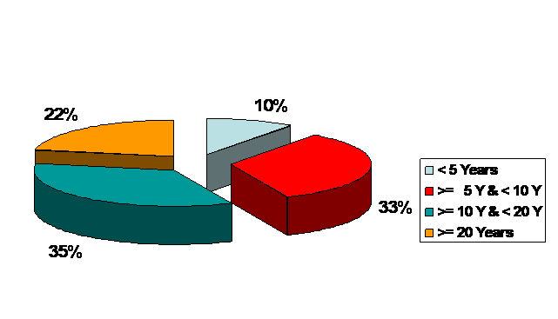
From Part I Question 1. How long have you been working in social insurance?

Figure 2 Working experience in social insurance

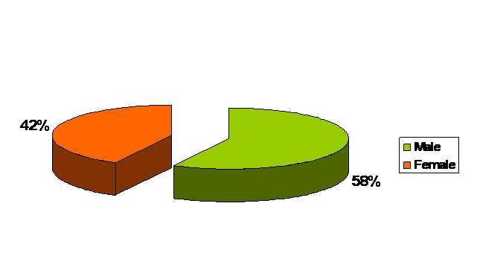
Only 10% of respondents have been working in social insurance for less than 5 years. The majority of respondents have been working for 5 – less than 20 years.

Gender

Figure 3 Gender

58% of respondents are males and 42% are females.

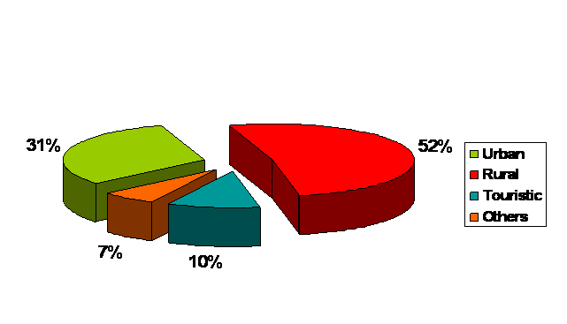
Area of work in social insurance

Figure 4 Area of work in social insurance

52% of respondents are working in rural areas, 31% are working in urban areas, 10% in touristic area and 7% in other areas.

Perception of suggested solutions
Part II Please rate Your agreement of each of the following suggested solutions according to the following attributes where 5 = Completely agree, 4 = Agree, 3 = Neither / nor, 2 = Don’t agree and 1 = Don’t agree at all

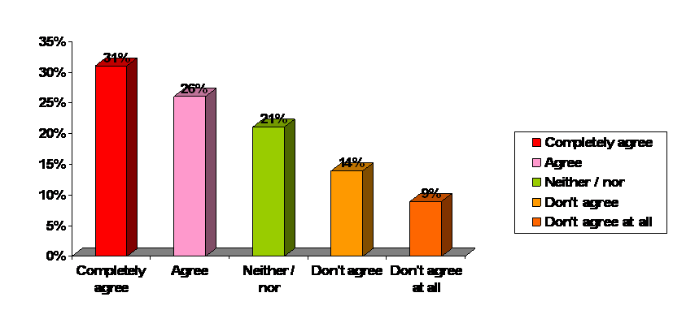
Serving customers from any Social Insurance Office

Figure 5 Agreement upon “Serving customers from any Social Insurance Office”

57% of respondents agree that “Serving customers from any Social Insurance Office” is perceived to improve customer satisfaction.

Increasing number of pension encashment
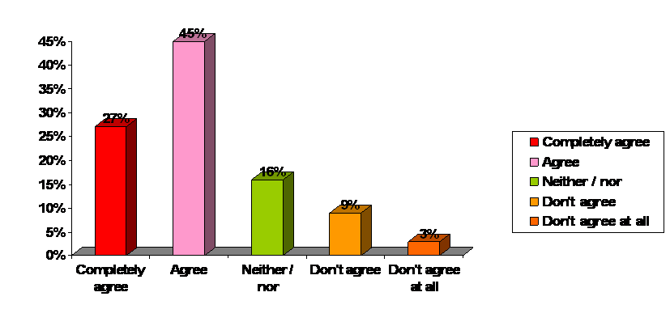

Figure 6 Agreement upon “Increasing number of pension encashment”

72% of respondents agree that “Increasing number of pension encashment” is perceived to improve customer satisfaction

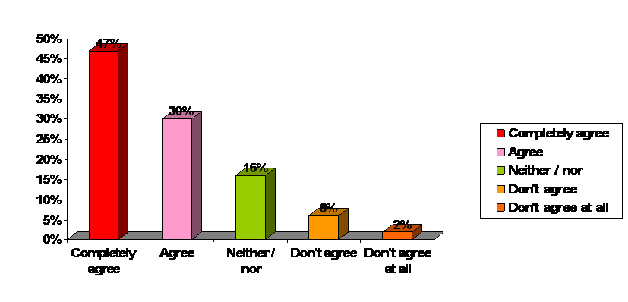
Consolidating employees back service period from Social Insurance Offices to be done periodically to insure accurate and fast delivery of pension

Figure 7 Agreement upon “Consolidating employees back service period from Social Insurance Offices to be done periodically to insure accurate and fast delivery of pension”

77% of respondents agree that “Consolidating employees back service period from Social Insurance Offices to be done periodically to insure accurate and fast delivery of pension” is perceived to improve customer satisfaction
Single point of contact in Social Insurance
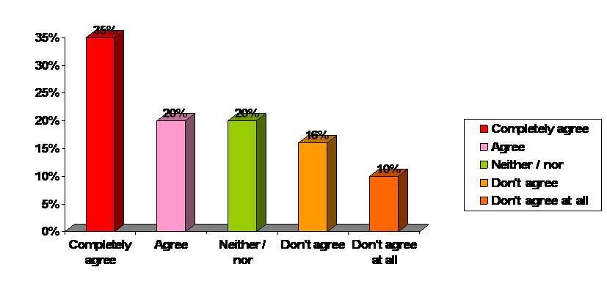

Figure 8 Agreement upon “Single point of contact in Social Insurance”

55% of respondents agree that “Single point of contact in Social Insurance” is perceived to improve customer satisfaction

Review, document and unify the current business processes and apply it in all Social Insurance offices
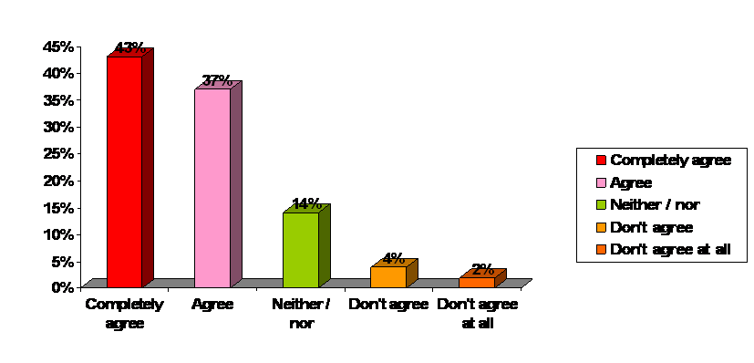

Figure 9 Agreement upon “Review, document and unify the current business processes and apply it in all Social Insurance offices”
80% of respondents agree that “Review, document and unify the current business processes and apply it in all Social Insurance offices” is perceived to improve customer satisfaction

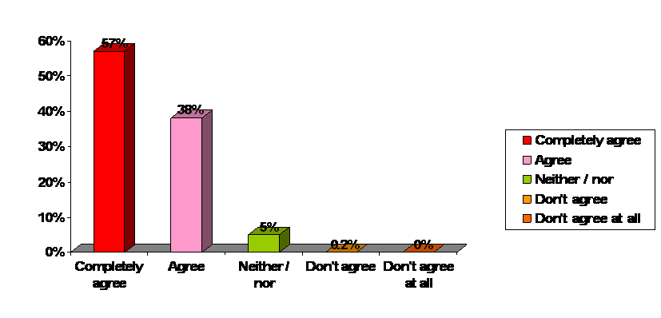
Implement a Call Center to follow up on the progress of customers' requests and to answer inquiries

Figure 10 Agreement upon “Implement a Call Center to follow up on the progress of customers' requests and to answer inquiries”
95% of respondents agree that “Implement a Call Center to follow up on the progress of customers' requests and to answer inquiries” is perceived to improve customer satisfaction

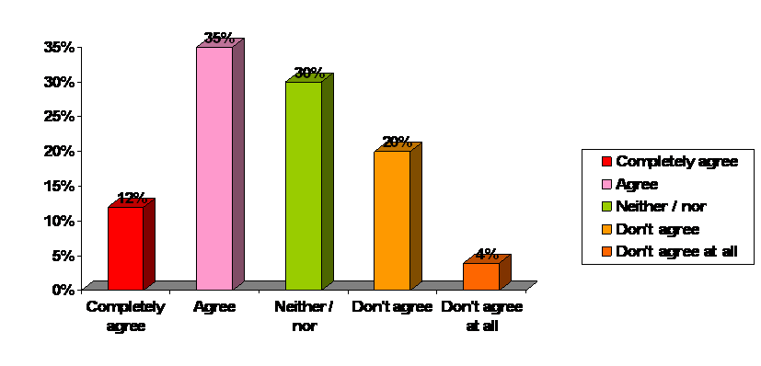
Continuously measure the quality and productivity of employees

Figure 11 Agreement upon “Continuously measure the quality and productivity of employees”

47% of respondents agree that “Continuously measure the quality and productivity of employees” is perceived to improve customer satisfaction

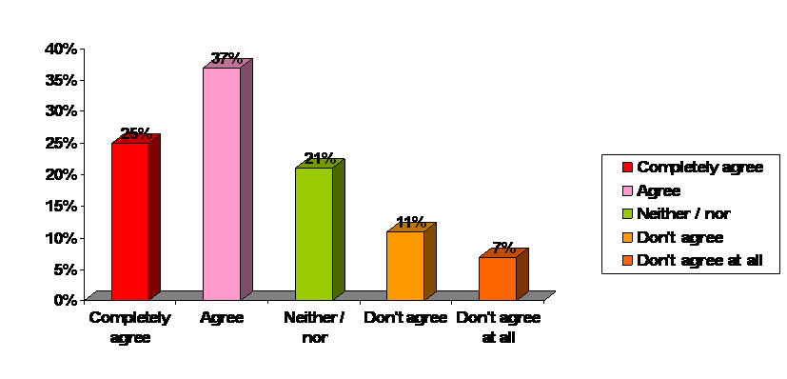
Implementing complaint / escalation and checking customer

Figure 12 Agreement upon “Implementing complaint / escalation and checking customer”

62% of respondents agree that “Implementing complaint / escalation and checking customer” is perceived to improve customer satisfaction

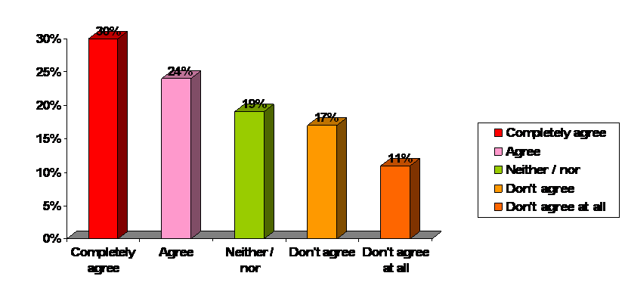
Provide other means of payment methods for Employers instead of the current manual method of payment

Figure 13 Agreement upon “Provide other means of payment methods for Employers instead of the current manual method of payment”

54% of respondents agree that “Implementing complaint / escalation and checking customer” is perceived to improve customer satisfaction

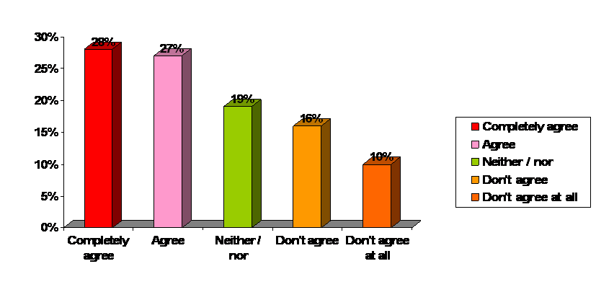
Improve Social Insurance Offices service environment

Figure 14 Agreement upon “Improve Social Insurance Offices service environment”

55% of respondents agree that “Improve Social Insurance Offices service environment” is perceived to improve customer satisfaction

Testing the differences between respondents perception about the value of the suggested solutions based upon their demographic variables.

A) Based upon years of work experience in social insurance

The study questions have been tested according to years of experience in social insurance.

To examine for questions, Pearson Chi-Square test is used to test the difference in perception as regards value of suggested solution in improving customers’ satisfaction; between groups of respondents according to years of experience in social insurance

1. Serving customers from any Social Insurance Office

Table 10 Breakdown of agreement on “Serving customers from any Social Insurance Office” based upon working experience in social insurance
 |  |  | How long have you been working in social insurance? |  |  |  | Total
 |  |  | < 5 Years | > 5 Y & < 10 Y | > 10 Y & < 20 Y | > 20 Years
 | Don't agree | Count | 14 | 27 | 26 | 24 | 91
 |  | % | 33.3% | 20.3% | 18.7% | 27.0% | 22.6%
 | Neither / nor | Count | 9 | 25 | 42 | 7 | 83
 |  | % | 21.4% | 18.8% | 30.2% | 7.9% | 20.6%
 | Agree | Count | 19 | 81 | 71 | 58 | 229
 |  | % | 45.2% | 60.9% | 51.1% | 65.2% | 56.8%
Total |  | Count | 42 | 133 | 139 | 89 | 403
 |  | % | 100.0% | 100.0% | 100.0% | 100.0% | 100.0%

45% of respondents having work experience in social insurance < 5 years agree that “Serving customers from any Social Insurance Office” would improve customer satisfaction compared to 61% of respondents with work experience > 5 years-< 10 years; 51% of respondents with work experience > 10 years-< 20 years and 65% of respondents with work experience > 20 years.

To test for the differences between these groups; Pearson Chi-Square test was done. Table 11 shows that these differences are statistically highly significant.

Table 11 Pearson Chi-Square test of the differences of agreement between groups upon “Serving customers from any Social Insurance Office” based upon their working experience in social insurance
 | Value | df | Asymp. Sig. (2-sided)
Pearson Chi-Square | 20.891 | 6 | 0.002

Respondents having work experience in social insurance < 5 years has less experience in the Social Insurance Field and also they have less interaction with customers as most of them are working in Back-office

2. Increasing number of pension encashment

Table 12 Breakdown of agreement on “Increasing number of pension encashment” based upon working experience in social insurance
 |  |  | How long have you been working in social insurance? |  |  |  | Total
 |  |  | < 5 Years | > 5 Y & < 10 Y | > 10 Y & < 20 Y | > 20 Years
 | Don't agree | Count | 4 | 16 | 14 | 14 | 48
 |  | % | 9.5% | 12.0% | 10.1% | 15.7% | 11.9%
 | Neither / nor | Count | 4 | 15 | 27 | 17 | 63
 |  | % | 9.5% | 11.3% | 19.4% | 19.1% | 15.6%
 | Agree | Count | 34 | 102 | 98 | 58 | 292
 |  | % | 81.0% | 76.7% | 70.5% | 65.2% | 72.5%
Total |  | Count | 42 | 133 | 139 | 89 | 403
 |  | % | 100.0% | 100.0% | 100.0% | 100.0% | 100.0%

81% of respondents having work experience in social insurance < 5 years agree that “Increasing number of pension encashment” would improve customer satisfaction compared to 77% of respondents with work experience > 5 years-< 10 years; 71% of respondents with work experience > 10 years-< 20 years and 65% of respondents with work experience > 20 years.

To test for the differences between these groups; Pearson Chi-Square test was done. Table 13 shows that these differences are statistically not significant.

Table 13 Pearson Chi-Square test of the differences of agreement between groups upon “Increasing number of pension encashment” based upon their working experience in social insurance
 | Value | df | Asymp. Sig. (2-sided)
Pearson Chi-Square | 7.740 | 6 | 0.258

Majority of all respondents without statistically significant inter-differences agree on increasing number of pension encashment.

3. Consolidating employees back service period from Social Insurance Offices to be done periodically to insure accurate and fast delivery of pension

Table 14 Breakdown of agreement on “Consolidating employees back service period from Social Insurance Offices to be done periodically to insure accurate and fast delivery of pension” based upon working experience in social insurance
 |  |  | How long have you been working in social insurance? |  |  |  | Total
 |  |  | < 5 Years | > 5 Y & < 10 Y | > 10 Y & < 20 Y | > 20 Years
 | Don't agree | Count | 7 | 6 | 8 | 7 | 28
 |  | % | 16.7% | 4.5% | 5.8% | 7.9% | 6.9%
 | Neither / nor | Count | 10 | 28 | 13 | 13 | 64
 |  | % | 23.8% | 21.1% | 9.4% | 14.6% | 15.9%
 | Agree | Count | 25 | 99 | 118 | 69 | 311
 |  | % | 59.5% | 74.4% | 84.9% | 77.5% | 77.2%
Total |  | Count | 42 | 133 | 139 | 89 | 403
 |  | % | 100.0% | 100.0% | 100.0% | 100.0% | 100.0%

60% of respondents having work experience in social insurance < 5 years agree that “Consolidating employees back service period from Social Insurance Offices to be done periodically to insure accurate and fast delivery of pension” would improve customer satisfaction compared to 74% of respondents with work experience > 5 years-< 10 years; 85% of respondents with work experience > 10 years-< 20 years and 78% of respondents with work experience > 20 years.

To test for the differences between these groups; Pearson Chi-Square test was done. Table 15 shows that these differences are statistically highly significant.

Table 15 Pearson Chi-Square test of the differences of agreement between groups upon “Consolidating employees back service period from Social Insurance Offices to be done periodically to insure accurate and fast delivery of pension” based upon their working experience in social insurance
 | Value | df | Asymp. Sig. (2-sided)
Pearson Chi-Square | 17.862 | 6 | 0.007

Respondents with fewer years of experience don’t have the foresight to perceive the impact upon customer satisfaction.

4. Single point of contact in Social Insurance

Table 16 Breakdown of agreement on “Single point of contact in Social Insurance” based upon working experience in social insurance
 |  |  | How long have you been working in social insurance? |  |  |  | Total
 |  |  | < 5 Years | > 5 Y & < 10 Y | > 10 Y & < 20 Y | > 20 Years
 | Don't agree | Count | 5 | 23 | 46 | 30 | 104
 |  | % | 11.9% | 17.3% | 33.1% | 33.7% | 25.8%
 | Neither / nor | Count | 15 | 32 | 15 | 17 | 79
 |  | % | 35.7% | 24.1% | 10.8% | 19.1% | 19.6%
 | Agree | Count | 22 | 78 | 78 | 42 | 220
 |  | % | 52.4% | 58.6% | 56.1% | 47.2% | 54.6%
Total |  | Count | 42 | 133 | 139 | 89 | 403
 |  | % | 100.0% | 100.0% | 100.0% | 100.0% | 100.0%

12% and 17% of respondents having work experience in social insurance < 5 years and > 5 years-< 10 years consequently disagree that ““Single point of contact in Social Insurance” would improve customer satisfaction compared to 33% of respondents with work experience > 10 years-< 20 years and 34% of respondents with work experience > 20 years.

To test for the differences between these groups; Pearson Chi-Square test was done. Table 17 shows that these differences are statistically very highly significant.

Table 17 Pearson Chi-Square test of the differences of agreement between groups upon “Single point of contact in Social Insurance” based upon their working experience in social insurance
 | Value | df | Asymp. Sig. (2-sided)
Pearson Chi-Square | 25.710 | 6 | 0.000

5. Review, document and unify the current business processes and apply it in all Social Insurance offices

Table 18 Breakdown of agreement on “Review, document and unify the current business processes and apply it in all Social Insurance offices” based upon working experience in social insurance
 |  |  | How long have you been working in social insurance? |  |  |  | Total
 |  |  | < 5 Years | > 5 Y & < 10 Y | > 10 Y & < 20 Y | > 20 Years
 | Don't agree | Count | 0 | 2 | 8 | 15 | 25
 |  | % | 0.0% | 1.5% | 5.8% | 17.0% | 6.2%
 | Neither / nor | Count | 2 | 4 | 29 | 21 | 56
 |  | % | 4.8% | 3.0% | 20.9% | 23.9% | 13.9%
 | Agree | Count | 40 | 127 | 102 | 52 | 321
 |  | % | 95.2% | 95.5% | 73.4% | 59.1% | 79.9%
Total |  | Count | 42 | 133 | 139 | 89 | 403
 |  | % | 100.0% | 100.0% | 100.0% | 100.0% | 100.0%

59% of respondents having work experience in social insurance > 20 years agree that “Review, document and unify the current business processes and apply it in all Social Insurance offices” would improve customer satisfaction compared to 73% of respondents with work experience > 10 years-< 20 years, 96% of respondents with work experience > 5 years-< 10 years and 95% of respondents with work experience < 5 years.

To test for the differences between these groups; Pearson Chi-Square test was done. Table 19 shows that these differences are statistically very highly significant.

Table 19 Pearson Chi-Square test of the differences of agreement between groups upon “Review, document and unify the current business processes and apply it in all Social Insurance offices” based upon their working experience in social insurance
 | Value | df | Asymp. Sig. (2-sided)
Pearson Chi-Square | 59.752 | 6 | 0.000

The more working period within the same organization, the more resistance to change in Business Processes as this category of employees thinks that the current Business Process is the best although a lot of changes in Information Technology and Service delivery methods have been introduced.

6. Implement a Call Center to follow up on the progress of customers’ requests and to answer inquiries

Table 20 Breakdown of agreement on “Implement a Call Center to follow up on the progress of customers’ requests and to answer inquiries” based upon working experience in social insurance
 |  |  | How long have you been working in social insurance? |  |  |  | Total
 |  |  | < 5 Years | > 5 Y & < 10 Y | > 10 Y & < 20 Y | > 20 Years
 | Don't agree | Count | 0 | 0 | 0 | 1 | 1
 |  | % | 0.0% | 0.0% | 0.0% | 1.1% | 0.2%
 | Neither / nor | Count | 0 | 2 | 11 | 8 | 21
 |  | % | 0.0% | 1.5% | 7.9% | 9.0% | 5.2%
 | Agree | Count | 42 | 131 | 128 | 80 | 381
 |  | % | 100.0% | 98.5% | 92.1% | 89.9% | 94.5%
Total |  | Count | 42 | 133 | 139 | 89 | 403
 |  | % | 100.0% | 100.0% | 100.0% | 100.0% | 100.0%

90% of respondents having work experience in social insurance > 20 years agree that “Implement a Call Center to follow up on the progress of customers’ requests and to answer inquiries” would improve customer satisfaction compared to 92% of respondents with work experience > 10 years-< 20 years, 99% of respondents with work experience > 5 years-< 10 years and 100% of respondents with work experience < 5 years.

To test for the differences between these groups; Pearson Chi-Square test was done. Table 21 shows that these differences are statistically significant.

Table 21 Pearson Chi-Square test of the differences of agreement between groups upon “Implement a Call Center to follow up on the progress of customers’ requests and to answer inquiries” based upon their working experience in social insurance
 | Value | df | Asymp. Sig. (2-sided)
Pearson Chi-Square | 14.255 | 6 | 0.027

Although the majority of respondents agree on this issue, however, respondents with higher work experience agreeing on it are significantly less than other groups. This group of respondents are in higher management position and so they are not in direct contact with customers.

7. Continuously measure the quality and productivity of employees

Table 22 Breakdown of agreement on “Continuously measure the quality and productivity of employees” based upon working experience in social insurance
 |  |  | How long have you been working in social insurance? |  |  |  | Total
 |  |  | < 5 Years | > 5 Y & < 10 Y | > 10 Y & < 20 Y | > 20 Years
 | Don't agree | Count | 8 | 16 | 36 | 34 | 94
 |  | % | 19.0% | 12.0% | 25.9% | 38.2% | 23.3%
 | Neither / nor | Count | 15 | 46 | 44 | 17 | 122
 |  | % | 35.7% | 34.6% | 31.7% | 19.1% | 30.3%
 | Agree | Count | 19 | 71 | 59 | 38 | 187
 |  | % | 45.2% | 53.4% | 42.4% | 42.7% | 46.4%
Total |  | Count | 42 | 133 | 139 | 89 | 403
 |  | % | 100.0% | 100.0% | 100.0% | 100.0% | 100.0%

38% of respondents having work experience in social insurance > 20 years disagree that “Continuously measure the quality and productivity of employees” would improve customer satisfaction compared to 26% of respondents with work experience > 10 years-< 20 years, 12% of respondents with work experience > 5 years-< 10 years and 19% of respondents with work experience < 5 years.

To test for the differences between these groups; Pearson Chi-Square test was done. Table 23 shows that these differences are statistically highly significant.

Table 23 Pearson Chi-Square test of the differences of agreement between groups upon “Continuously measure the quality and productivity of employees” based upon their working experience in social insurance
 | Value | df | Asymp. Sig. (2-sided)
Pearson Chi-Square | 23.571 | 6 | 0.001

The reason behind that more respondents with work experience > 20 years disagree on this issue more than other groups is their perception that their employment age is high to be re-evaluated or assessed

8. Implementing complaint / escalation and checking customer

Table 24 Breakdown of agreement on “Implementing complaint / escalation and checking customer” based upon working experience in social insurance
 |  |  | How long have you been working in social insurance? |  |  |  | Total
 |  |  | < 5 Years | > 5 Y & < 10 Y | > 10 Y & < 20 Y | > 20 Years
 | Don't agree | Count | 1 | 11 | 24 | 36 | 72
 |  | % | 2.4% | 8.3% | 17.3% | 40.4% | 17.9%
 | Neither / nor | Count | 14 | 25 | 32 | 13 | 84
 |  | % | 33.3% | 18.8% | 23.0% | 14.6% | 20.8%
 | Agree | Count | 27 | 97 | 83 | 40 | 247
 |  | % | 64.3% | 72.9% | 59.7% | 44.9% | 61.3%
Total |  | Count | 42 | 133 | 139 | 89 | 403
 |  | % | 100.0% | 100.0% | 100.0% | 100.0% | 100.0%

45% of respondents having work experience in social insurance > 20 years agree that “Implementing complaint / escalation and checking customer” would improve customer satisfaction compared to 60% of respondents with work experience > 10 years-< 20 years, 73% of respondents with work experience > 5 years-< 10 years and 63% of respondents with work experience < 5 years.

To test for the differences between these groups; Pearson Chi-Square test was done. Table 25 shows that these differences are statistically very highly significant.

Table 25 Pearson Chi-Square test of the differences of agreement between groups upon “Implementing complaint / escalation and checking customer” based upon their working experience in social insurance
 | Value | df | Asymp. Sig. (2-sided)
Pearson Chi-Square | 50.252 | 6 | 0.000

The reason behind that more respondents with work experience > 20 years agree on this issue more than other groups is that they have work load relatively more than other groups

9. Provide other means of payment methods for Employers instead of the current manual method of payment

Table 26 Breakdown of agreement on “Provide other means of payment methods for Employers instead of the current manual method of payment” based upon working experience in social insurance
 |  |  | How long have you been working in social insurance? |  |  |  | Total
 |  |  | < 5 Years | > 5 Y & < 10 Y | > 10 Y & < 20 Y | > 20 Years
 | Don't agree | Count | 6 | 32 | 50 | 24 | 112
 |  | % | 14.3% | 24.1% | 36.0% | 27.0% | 27.8%
 | Neither / nor | Count | 12 | 25 | 24 | 15 | 76
 |  | % | 28.6% | 18.8% | 17.3% | 16.9% | 18.9%
 | Agree | Count | 24 | 76 | 65 | 50 | 215
 |  | % | 57.1% | 57.1% | 46.8% | 56.2% | 53.3%
Total |  | Count | 42 | 133 | 139 | 89 | 403
 |  | % | 100.0% | 100.0% | 100.0% | 100.0% | 100.0%

56% of respondents having work experience in social insurance > 20 years agree that “Provide other means of payment methods for Employers instead of the current manual method of payment” would improve customer satisfaction compared to 47% of respondents with work experience > 10 years-< 20 years, 57% of respondents with work experience > 5 years-< 10 years and 57% of respondents with work experience < 5 years.

To test for the differences between these groups; Pearson Chi-Square test was done. Table 27 shows that these differences are statistically not significant.

Table 27 Pearson Chi-Square test of the differences of agreement between groups upon “Provide other means of payment methods for Employers instead of the current manual method of payment” based upon their working experience in social insurance
 | Value | df | Asymp. Sig. (2-sided)
Pearson Chi-Square | 11.005 | 6 | 0.088

The reason behind that no difference between respondents is that this issue would impact positively all respondents
10. Improve Social Insurance Offices service environment

Table 28 Breakdown of agreement on “Improve Social Insurance Offices service environment” based upon working experience in social insurance
 |  |  | How long have you been working in social insurance? |  |  |  | Total
 |  |  | < 5 Years | > 5 Y & < 10 Y | > 10 Y & < 20 Y | > 20 Years
 | Don't agree | Count | 6 | 30 | 50 | 20 | 106
 |  | % | 14.3% | 22.6% | 36.0% | 22.5% | 26.3%
 | Neither / nor | Count | 8 | 39 | 15 | 15 | 77
 |  | % | 19.0% | 29.3% | 10.8% | 16.9% | 19.1%
 | Agree | Count | 28 | 64 | 74 | 54 | 220
 |  | % | 66.7% | 48.1% | 53.2% | 60.7% | 54.6%
Total |  | Count | 42 | 133 | 139 | 89 | 403
 |  | % | 100.0% | 100.0% | 100.0% | 100.0% | 100.0%

67% of respondents having work experience in social insurance < 5 years agree that “Increasing number of pension encashment” would improve customer satisfaction compared to 48% of respondents with work experience > 5 years-< 10 years; 53% of respondents with work experience > 10 years-< 20 years and 61% of respondents with work experience > 20 years.

To test for the differences between these groups; Pearson Chi-Square test was done. Table 29 shows that these differences are statistically highly significant.

Table 29 Pearson Chi-Square test of the differences of agreement between groups upon “Improve Social Insurance Offices service environment” based upon their working experience in social insurance
 | Value | df | Asymp. Sig. (2-sided)
Pearson Chi-Square | 23.777 | 6 | 0.001

Respondents with years of experience < 5 years agree statistically significant more than other groups because they are new in the Social Insurance offices, accordingly they have a better vision for office environment weaknesses.

B) Based upon location of Social Insurance Office

1. Serving customers from any Social Insurance Office

Table 30 Breakdown of agreement on “Serving customers from any Social Insurance Office” based upon location of social insurance office
 |  |  | The location of your office is in |  |  |  | Total
 |  |  | Urban area | Rural area | Touristic area | Others
 | Don't agree | Count | 16 | 69 | 4 | 2 | 91
 |  | % | 12.8% | 32.9% | 9.5% | 7.7% | 22.6%
 | Neither / nor | Count | 23 | 47 | 11 | 2 | 83
 |  | % | 18.4% | 22.4% | 26.2% | 7.7% | 20.6%
 | Agree | Count | 86 | 94 | 27 | 22 | 229
 |  | % | 68.8% | 44.8% | 64.3% | 84.6% | 56.8%
Total |  | Count | 125 | 210 | 42 | 26 | 403
 |  | % | 100.0% | 100.0% | 100.0% | 100.0% | 100.0%

45% of respondents working in rural area agree that “Serving customers from any Social Insurance Office” would improve customer satisfaction compared to 64% of respondents working in touristic area; 69% of urban area and 85% of respondents working in other areas.

To test for the differences between these groups; Pearson Chi-Square test was done. Table 31 shows that these differences are statistically very highly significant.

Table 31 Pearson Chi-Square test of the differences of agreement between groups upon “Serving customers from any Social Insurance Office” based upon their location of social insurance office
 | Value | df | Asymp. Sig. (2-sided)
Pearson Chi-Square | 36.675 | 6 | 0.000

Less percentage of respondents working in rural area compared to other respondents agree on this issue because according to the rural culture; people rarely go outside the area they live in. for this reason, they perceive that there is no need to offer the service from other offices apart from the office the customer is belonging to it.

2. Increasing number of pension encashment

Table 32 Breakdown of agreement on “Increasing number of pension encashment” based upon location of social insurance office
 |  |  | The location of your office is in |  |  |  | Total
 |  |  | Urban area | Rural area | Touristic area | Others
 | Don't agree | Count | 0 | 41 | 7 | 0 | 48
 |  | % | 0.0% | 19.5% | 16.7% | 0.0% | 11.9%
 | Neither / nor | Count | 16 | 39 | 3 | 5 | 63
 |  | % | 12.8% | 18.6% | 7.1% | 19.2% | 15.6%
 | Agree | Count | 109 | 130 | 32 | 21 | 292
 |  | % | 87.2% | 61.9% | 76.2% | 80.8% | 72.5%
Total |  | Count | 125 | 210 | 42 | 26 | 403
 |  | % | 100.0% | 100.0% | 100.0% | 100.0% | 100.0%

62% of respondents working in rural area agree that “Increasing number of pension encashment” would improve customer satisfaction compared to 76% of respondents working in touristic area; 87% of urban area and 81% of respondents working in other areas.

To test for the differences between these groups; Pearson Chi-Square test was done. Table 33 shows that these differences are statistically very highly significant.

Table 33 Pearson Chi-Square test of the differences of agreement between groups upon “Increasing number of pension encashment” based upon their location of social insurance office
 | Value | df | Asymp. Sig. (2-sided)
Pearson Chi-Square | 40.261 | 6 | 0.000

Less percentage of respondents working in rural area compared to other respondents agree on this issue because according to the rural culture; the time factor is of less important so waiting for any period to get the pension is well tolerated. In addition; the ability to tolerate the waiting time for rural people is much more than other areas.

3. Consolidating employees back service period from Social Insurance Offices to be done periodically to insure accurate and fast delivery of pension

Table 34 Breakdown of agreement on “Consolidating employees back service period from Social Insurance Offices to be done periodically to insure accurate and fast delivery of pension” based upon location of social insurance office
 |  |  | The location of your office is in |  |  |  | Total
 |  |  | Urban area | Rural area | Touristic area | Others
 | Don't agree | Count | 2 | 25 | 0 | 1 | 28
 |  | % | 1.6% | 11.9% | 0.0% | 3.8% | 6.9%
 | Neither / nor | Count | 6 | 50 | 2 | 6 | 64
 |  | % | 4.8% | 23.8% | 4.8% | 23.1% | 15.9%
 | Agree | Count | 117 | 135 | 40 | 19 | 311
 |  | % | 93.6% | 64.3% | 95.2% | 73.1% | 77.2%
Total |  | Count | 125 | 210 | 42 | 26 | 403
 |  | % | 100.0% | 100.0% | 100.0% | 100.0% | 100.0%

95% of respondents working in touristic area and 94% of respondents working in urban area agree that “Consolidating employees back service period from Social Insurance Offices to be done periodically to insure accurate and fast delivery of pension” would improve customer satisfaction compared to 64% of respondents working in rural area; and 73% of respondents working in other areas.

To test for the differences between these groups; Pearson Chi-Square test was done. Table 35 shows that these differences are statistically very highly significant.

Table 35 Pearson Chi-Square test of the differences of agreement between groups upon “Consolidating employees back service period from Social Insurance Offices to be done periodically to insure accurate and fast delivery of pension” based upon their location of social insurance office
 | Value | df | Asymp. Sig. (2-sided)
Pearson Chi-Square | 48.668 | 6 | 0.000

In both touristic and urban areas, insured people frequently changes their employers, however in rural areas they prefer to stabilize within the same employer

4. Single point of contact in Social Insurance

Table 36 Breakdown of agreement on “Single point of contact in Social Insurance” based upon location of social insurance office
 |  |  | The location of your office is in |  |  |  | Total
 |  |  | Urban area | Rural area | Touristic area | Others
 | Don't agree | Count | 0 | 100 | 0 | 4 | 104
 |  | % | 0.0% | 47.6% | 0.0% | 15.4% | 25.8%
 | Neither / nor | Count | 4 | 67 | 4 | 4 | 79
 |  | % | 3.2% | 31.9% | 9.5% | 15.4% | 19.6%
 | Agree | Count | 121 | 43 | 38 | 18 | 220
 |  | % | 96.8% | 20.5% | 90.5% | 69.2% | 54.6%
Total |  | Count | 125 | 210 | 42 | 26 | 403
 |  | % | 100.0% | 100.0% | 100.0% | 100.0% | 100.0%

21% of respondents working in rural area agree that “Single point of contact in Social Insurance” would improve customer satisfaction compared to 91% of respondents working in touristic area; 97% of urban area and 69% of respondents working in other areas.

To test for the differences between these groups; Pearson Chi-Square test was done. Table 37 shows that these differences are statistically very highly significant.

Table 37 Pearson Chi-Square test of the differences of agreement between groups upon “Single point of contact in Social Insurance” based upon their location of social insurance office
 | Value | df | Asymp. Sig. (2-sided)
Pearson Chi-Square | 215.182 | 6 | 0.000

In rural areas, number of employees within offices is relatively matching the number of customers to be served. In rural areas, customer prefer to be served face to face with employees

5. Review, document and unify the current business processes and apply it in all Social Insurance offices

Table 38 Breakdown of agreement on “Review, document and unify the current business processes and apply it in all Social Insurance offices” based upon location of social insurance office
 |  |  | The location of your office is in |  |  |  | Total
 |  |  | Urban area | Rural area | Touristic area | Others
 | Don't agree | Count | 0 | 24 | 1 | 0 | 25
 |  | % | 0.0% | 11.4% | 2.4% | 0.0% | 6.2%
 | Neither / nor | Count | 10 | 42 | 1 | 3 | 56
 |  | % | 8.0% | 20.0% | 2.4% | 11.5% | 13.9%
 | Agree | Count | 115 | 144 | 39 | 23 | 321
 |  | % | 92.0% | 68.6% | 95.1% | 88.5% | 79.9%
Total |  | Count | 125 | 210 | 42 | 26 | 403
 |  | % | 100.0% | 100.0% | 100.0% | 100.0% | 100.0%

69% of respondents working in rural area agree that “Review, document and unify the current business processes and apply it in all Social Insurance offices” would improve customer satisfaction compared to 92% of respondents working in urban area; 95% of touristic area and 89% of respondents working in other areas.

To test for the differences between these groups; Pearson Chi-Square test was done. Table 39 shows that these differences are statistically very highly significant.

Table 39 Pearson Chi-Square test of the differences of agreement between groups upon “Review, document and unify the current business processes and apply it in all Social Insurance offices” based upon their location of social insurance office
 | Value | df | Asymp. Sig. (2-sided)
Pearson Chi-Square | 39.296 | 6 | 0.000

In rural areas, employees feel satisfied with their current situation in their business processes.

6. Implement a Call Center to follow up on the progress of customers’ requests and to answer inquiries

Table 40 Breakdown of agreement on “Implement a Call Center to follow up on the progress of customers’ requests and to answer inquiries” based upon location of social insurance office
 |  |  | The location of your office is in |  |  |  | Total
 |  |  | Urban area | Rural area | Touristic area | Others
 | Don't agree | Count | 0 | 0 | 1 | 0 | 1
 |  | % | 0.0% | 0.0% | 2.4% | 0.0% | 0.2%
 | Neither / nor | Count | 1 | 11 | 4 | 5 | 21
 |  | % | 0.8% | 5.2% | 9.5% | 19.2% | 5.2%
 | Agree | Count | 124 | 199 | 37 | 21 | 381
 |  | % | 99.2% | 94.8% | 88.1% | 80.8% | 94.5%
Total |  | Count | 125 | 210 | 42 | 26 | 403
 |  | % | 100.0% | 100.0% | 100.0% | 100.0% | 100.0%

99% of respondents working in urban area agree that “Implement a Call Center to follow up on the progress of customers’ requests and to answer inquiries” would improve customer satisfaction compared to 95% of respondents working in rural area; 88% of touristic area and 81% of respondents working in other areas.

To test for the differences between these groups; Pearson Chi-Square test was done. Table 41 shows that these differences are statistically very highly significant.

Table 41 Pearson Chi-Square test of the differences of agreement between groups upon “Implement a Call Center to follow up on the progress of customers’ requests and to answer inquiries” based upon their location of social insurance office
 | Value | df | Asymp. Sig. (2-sided)
Pearson Chi-Square | 25.563 | 6 | 0.000

The highest rate of acceptance is in the urban areas, due to the fact that very high number of customers could be served by Call Center

7. Continuously measure the quality and productivity of employees

Table 42 Breakdown of agreement on “Continuously measure the quality and productivity of employees” based upon location of social insurance office
 |  |  | The location of your office is in |  |  |  | Total
 |  |  | Urban area | Rural area | Touristic area | Others
 | Don't agree | Count | 21 | 64 | 6 | 3 | 94
 |  | % | 16.8% | 30.5% | 14.3% | 11.5% | 23.3%
 | Neither / nor | Count | 27 | 70 | 13 | 12 | 122
 |  | % | 21.6% | 33.3% | 31.0% | 46.2% | 30.3%
 | Agree | Count | 77 | 76 | 23 | 11 | 187
 |  | % | 61.6% | 36.2% | 54.8% | 42.3% | 46.4%
Total |  | Count | 125 | 210 | 42 | 26 | 403
 |  | % | 100.0% | 100.0% | 100.0% | 100.0% | 100.0%

36% of respondents working in rural area agree that “Continuously measure the quality and productivity of employees” would improve customer satisfaction compared to 55% of respondents working in touristic area; 62% of urban area and 42% of respondents working in other areas.

To test for the differences between these groups; Pearson Chi-Square test was done. Table 43 shows that these differences are statistically very highly significant.

Table 43 Pearson Chi-Square test of the differences of agreement between groups upon “Continuously measure the quality and productivity of employees” based upon their location of social insurance office
 | Value | df | Asymp. Sig. (2-sided)
Pearson Chi-Square | 27.502 | 6 | 0.000

The highest rate of acceptance is in the urban areas, due to the fact that very high number of customers could be served by Call Center

8. Implementing complaint / escalation and checking customer

Table 44 Breakdown of agreement on “Implementing complaint / escalation and checking customer” based upon location of social insurance office
 |  |  | The location of your office is in |  |  |  | Total
 |  |  | Urban area | Rural area | Touristic area | Others
 | Don't agree | Count | 34 | 16 | 17 | 5 | 72
 |  | % | 27.2% | 7.6% | 40.5% | 19.2% | 17.9%
 | Neither / nor | Count | 42 | 33 | 3 | 6 | 84
 |  | % | 33.6% | 15.7% | 7.1% | 23.1% | 20.8%
 | Agree | Count | 49 | 161 | 22 | 15 | 247
 |  | % | 39.2% | 76.7% | 52.4% | 57.7% | 61.3%
Total |  | Count | 125 | 210 | 42 | 26 | 403
 |  | % | 100.0% | 100.0% | 100.0% | 100.0% | 100.0%

39% of respondents working in urban area agree that “Implementing complaint / escalation and checking customer” would improve customer satisfaction compared to 52% of respondents working in touristic area; 77% of rural area and 58% of respondents working in other areas.

To test for the differences between these groups; Pearson Chi-Square test was done. Table 45 shows that these differences are statistically very highly significant.

Table 45 Pearson Chi-Square test of the differences of agreement between groups upon “Implementing complaint / escalation and checking customer” based upon their location of social insurance office
 | Value | df | Asymp. Sig. (2-sided)
Pearson Chi-Square | 65.389 | 6 | 0.000

The lowest rate of acceptance in Urban areas as the complain system will add a workload to employees of those offices specially offices are suffering from the increased number of customers relative to number of employees

9. Provide other means of payment methods for Employers instead of the current manual method of payment

Table 46 Breakdown of agreement on “Provide other means of payment methods for Employers instead of the current manual method of payment” based upon location of social insurance office
 |  |  | The location of your office is in |  |  |  | Total
 |  |  | Urban area | Rural area | Touristic area | Others
 | Don't agree | Count | 0 | 112 | 0 | 0 | 112
 |  | % | 0.0% | 53.3% | 0.0% | 0.0% | 27.8%
 | Neither / nor | Count | 1 | 69 | 2 | 4 | 76
 |  | % | 0.8% | 32.9% | 4.8% | 15.4% | 18.9%
 | Agree | Count | 124 | 29 | 40 | 22 | 215
 |  | % | 99.2% | 13.8% | 95.2% | 84.6% | 53.3%
Total |  | Count | 125 | 210 | 42 | 26 | 403
 |  | % | 100.0% | 100.0% | 100.0% | 100.0% | 100.0%

14% of respondents working in rural area agree that “Provide other means of payment methods for Employers instead of the current manual method of payment” would improve customer satisfaction compared to 95% of respondents working in touristic area; 99% of rural area and 85% of respondents working in other areas.

To test for the differences between these groups; Pearson Chi-Square test was done. Table 47 shows that these differences are statistically very highly significant.

Table 47 Pearson Chi-Square test of the differences of agreement between groups upon “Provide other means of payment methods for Employers instead of the current manual method of payment” based upon their location of social insurance office
 | Value | df | Asymp. Sig. (2-sided)
Pearson Chi-Square | 280.337 | 6 | 0.000

The lowest rate of acceptance in rural areas due to the low number of Employers within the geographical location of those offices and accordingly less contribution cash to be held in the office

10. Improve Social Insurance Offices service environment

Table 48 Breakdown of agreement on “Improve Social Insurance Offices service environment” based upon location of social insurance office
 |  |  | The location of your office is in |  |  |  | Total
 |  |  | Urban area | Rural area | Touristic area | Others
 | Don't agree | Count | 0 | 99 | 7 | 0 | 106
 |  | % | 0.0% | 47.1% | 16.7% | 0.0% | 26.3%
 | Neither / nor | Count | 1 | 65 | 4 | 7 | 77
 |  | % | 0.8% | 31.0% | 9.5% | 26.9% | 19.1%
 | Agree | Count | 124 | 46 | 31 | 19 | 220
 |  | % | 99.2% | 21.9% | 73.8% | 73.1% | 54.6%
Total |  | Count | 125 | 210 | 42 | 26 | 403
 |  | % | 100.0% | 100.0% | 100.0% | 100.0% | 100.0%

22% of respondents working in rural area agree that “Improve Social Insurance Offices service environment” would improve customer satisfaction compared to 74% of respondents working in touristic area; 99% of urban area and 73% of respondents working in other areas.

To test for the differences between these groups; Pearson Chi-Square test was done. Table 49 shows that these differences are statistically very highly significant.

Table 49 Pearson Chi-Square test of the differences of agreement between groups upon “Improve Social Insurance Offices service environment” based upon their location of social insurance office
 | Value | df | Asymp. Sig. (2-sided)
Pearson Chi-Square | 207.207 | 6 | 0.000

The lowest rate of acceptance in rural areas due to the low number of Employers within the geographical location of those offices. Moreover, rural people are more tolerant to the surrounding environment.

C) Based upon gender

1. Serving customers from any Social Insurance Office

Table 50 Breakdown of agreement on “Serving customers from any Social Insurance Office” based upon gender
 |  |  | Gender |  | Total
 |  |  | Male | Female
 | Don't agree | Count | 54 | 37 | 91
 |  | % | 23.2% | 21.8% | 22.6%
 | Neither / nor | Count | 52 | 31 | 83
 |  | % | 22.3% | 18.2% | 20.6%
 | Agree | Count | 127 | 102 | 229
 |  | % | 54.5% | 60.0% | 56.8%
Total |  | Count | 233 | 170 | 403
 |  | % | 100.0% | 100.0% | 100.0%

60% of female respondents agree that “Serving customers from any Social Insurance Office” would improve customer satisfaction compared to 55% of male respondents.

To test for the differences between these groups; Pearson Chi-Square test was done. Table 51 shows that these differences are statistically not significant.

Table 51 Pearson Chi-Square test of the differences of agreement between groups upon “Serving customers from any Social Insurance Office” based upon their gender
 | Value | df | Asymp. Sig. (2-sided)
Pearson Chi-Square | 1.404 | 2 | 0.496

2. Increasing number of pension encashment

Table 52 Breakdown of agreement on “Increasing number of pension encashment” based upon gender
 |  |  | Gender |  | Total
 |  |  | Male | Female
 | Don't agree | Count | 29 | 19 | 48
 |  | % | 12.4% | 11.2% | 11.9%
 | Neither / nor | Count | 29 | 34 | 63
 |  | % | 12.4% | 20.0% | 15.6%
 | Agree | Count | 175 | 117 | 292
 |  | % | 75.1% | 68.8% | 72.5%
Total |  | Count | 233 | 170 | 403
 |  | % | 100.0% | 100.0% | 100.0%

75% of male respondents agree that “Increasing number of pension encashment” would improve customer satisfaction compared to 69% of female respondents.

To test for the differences between these groups; Pearson Chi-Square test was done. Table 53 shows that these differences are statistically not significant.

Table 53 Pearson Chi-Square test of the differences of agreement between groups upon “Increasing number of pension encashment” based upon their gender
 | Value | df | Asymp. Sig. (2-sided)
Pearson Chi-Square | 4.256 | 2 | 0.119

3. Consolidating employees back service period from Social Insurance Offices to be done periodically to insure accurate and fast delivery of pension

Table 54 Breakdown of agreement on “Consolidating employees back service period from Social Insurance Offices to be done periodically to insure accurate and fast delivery of pension” based upon gender
 |  |  | Gender |  | Total
 |  |  | Male | Female
 | Don't agree | Count | 19 | 9 | 28
 |  | % | 8.2% | 5.3% | 6.9%
 | Neither / nor | Count | 46 | 18 | 64
 |  | % | 19.7% | 10.6% | 15.9%
 | Agree | Count | 168 | 143 | 311
 |  | % | 72.1% | 84.1% | 77.2%
Total |  | Count | 233 | 170 | 403
 |  | % | 100.0% | 100.0% | 100.0%

84% of female respondents agree that “Consolidating employees back service period from Social Insurance Offices to be done periodically to insure accurate and fast delivery of pension” would improve customer satisfaction compared to 72% of male respondents.

To test for the differences between these groups; Pearson Chi-Square test was done. Table 55 shows that these differences are statistically significant.

Table 55 Pearson Chi-Square test of the differences of agreement between groups upon “Consolidating employees back service period from Social Insurance Offices to be done periodically to insure accurate and fast delivery of pension” based upon their gender
 | Value | df | Asymp. Sig. (2-sided)
Pearson Chi-Square | 8.182 | 2 | 0.017

4. Single point of contact in Social Insurance

Table 56 Breakdown of agreement on “Single point of contact in Social Insurance” based upon gender
 |  |  | Gender |  | Total
 |  |  | Male | Female
 | Don't agree | Count | 54 | 50 | 104
 |  | % | 23.2% | 29.4% | 25.8%
 | Neither / nor | Count | 51 | 28 | 79
 |  | % | 21.9% | 16.5% | 19.6%
 | Agree | Count | 128 | 92 | 220
 |  | % | 54.9% | 54.1% | 54.6%
Total |  | Count | 233 | 170 | 403
 |  | % | 100.0% | 100.0% | 100.0%

55% of male respondents agree that “Single point of contact in Social Insurance” would improve customer satisfaction compared to 54% of female respondents.

To test for the differences between these groups; Pearson Chi-Square test was done. Table 57 shows that these differences are statistically not significant.

Table 57 Pearson Chi-Square test of the differences of agreement between groups upon “Single point of contact in Social Insurance” based upon their gender
 | Value | df | Asymp. Sig. (2-sided)
Pearson Chi-Square | 2.965 | 2 | 0.227

5. Review, document and unify the current business processes and apply it in all Social Insurance offices

Table 58 Breakdown of agreement on “Review, document and unify the current business processes and apply it in all Social Insurance offices” based upon gender
 |  |  | Gender |  | Total
 |  |  | Male | Female
 | Don't agree | Count | 6 | 19 | 25
 |  | % | 2.6% | 11.2% | 6.2%
 | Neither / nor | Count | 20 | 36 | 56
 |  | % | 8.6% | 21.3% | 13.9%
 | Agree | Count | 207 | 114 | 321
 |  | % | 88.8% | 67.5% | 79.9%
Total |  | Count | 233 | 170 | 403
 |  | % | 100.0% | 100.0% | 100.0%

88% of male respondents agree that “Review, document and unify the current business processes and apply it in all Social Insurance offices” would improve customer satisfaction compared to 68% of female respondents.

To test for the differences between these groups; Pearson Chi-Square test was done. Table 59 shows that these differences are statistically very highly significant.

Table 59 Pearson Chi-Square test of the differences of agreement between groups upon “Review, document and unify the current business processes and apply it in all Social Insurance offices” based upon their gender
 | Value | df | Asymp. Sig. (2-sided)
Pearson Chi-Square | 28.817 | 2 | 0.000

Male respondents are more inclined to practical issues by culture upbringings, this is the most likely reason to agree on this issue more than their female colleague.

6. Implement a Call Center to follow up on the progress of customers’ requests and to answer inquiries

Table 60 Breakdown of agreement on “Implement a Call Center to follow up on the progress of customers’ requests and to answer inquiries” based upon gender

 |  |  | Gender |  | Total
 |  |  | Male | Female
 | Don't agree | Count | 0 | 1 | 1
 |  | % | 0.0% | 0.6% | 0.2%
 | Neither / nor | Count | 4 | 17 | 21
 |  | % | 1.7% | 10.0% | 5.2%
 | Agree | Count | 229 | 152 | 381
 |  | % | 98.3% | 89.4% | 94.5%
Total |  | Count | 233 | 170 | 403
 |  | % | 100.0% | 100.0% | 100.0%

98% of male respondents agree that “Implement a Call Center to follow up on the progress of customers’ requests and to answer inquiries” would improve customer satisfaction compared to 89% of female respondents.

To test for the differences between these groups; Pearson Chi-Square test was done. Table 61 shows that these differences are statistically highly significant.

Table 61 Pearson Chi-Square test of the differences of agreement between groups upon “Implement a Call Center to follow up on the progress of customers’ requests and to answer inquiries” based upon their gender
 | Value | df | Asymp. Sig. (2-sided)
Pearson Chi-Square | 15.130 | 2 | 0.001

7. Continuously measure the quality and productivity of employees

Table 62 Breakdown of agreement on “Continuously measure the quality and productivity of employees” based upon gender
 |  |  | Gender |  | Total
 |  |  | Male | Female
 | Don't agree | Count | 35 | 59 | 94
 |  | % | 15.0% | 34.7% | 23.3%
 | Neither / nor | Count | 73 | 49 | 122
 |  | % | 31.3% | 28.8% | 30.3%
 | Agree | Count | 125 | 62 | 187
 |  | % | 53.6% | 36.5% | 46.4%
Total |  | Count | 233 | 170 | 403
 |  | % | 100.0% | 100.0% | 100.0%

54% of male respondents agree that “Continuously measure the quality and productivity of employees” would improve customer satisfaction compared to 37% of female respondents.

To test for the differences between these groups; Pearson Chi-Square test was done. Table 63 shows that these differences are statistically very highly significant.

Table 63 Pearson Chi-Square test of the differences of agreement between groups upon “Continuously measure the quality and productivity of employees” based upon their gender
 | Value | df | Asymp. Sig. (2-sided)
Pearson Chi-Square | 22.782 | 2 | 0.000

More males significantly agree than females because they feel that they work more than females because the overtime work burden lies on males only. Beside that the law gives the females the right to work half the hours to raise children. It gives females the right to work daily hours less than males.

8. Implementing complaint / escalation and checking customer

Table 64 Breakdown of agreement on “Implementing complaint / escalation and checking customer” based upon gender
 |  |  | Gender |  | Total
 |  |  | Male | Female
 | Don't agree | Count | 23 | 49 | 72
 |  | % | 9.9% | 28.8% | 17.9%
 | Neither / nor | Count | 46 | 38 | 84
 |  | % | 19.7% | 22.4% | 20.8%
 | Agree | Count | 164 | 83 | 247
 |  | % | 70.4% | 48.8% | 61.3%
Total |  | Count | 233 | 170 | 403
 |  | % | 100.0% | 100.0% | 100.0%

70% of male respondents agree that “Continuously measure the quality and productivity of employees” would improve customer satisfaction compared to 49% of female respondents.

To test for the differences between these groups; Pearson Chi-Square test was done. Table 63 showed that these differences are statistically very highly significant.

Table 65 Pearson Chi-Square test of the differences of agreement between groups upon “Implementing complaint / escalation and checking customer” based upon their gender
 | Value | df | Asymp. Sig. (2-sided)
Pearson Chi-Square | 27.538 | 2 | 0.000

Most of employees working in offices with high density of customers are females. The evaluation represents a burden of overwork for them especially that these offices are suffering from huge number of customers and few employees.

9. Provide other means of payment methods for Employers instead of the current manual method of payment

Table 66 Breakdown of agreement on “Provide other means of payment methods for Employers instead of the current manual method of payment” based upon gender
 |  |  | Gender |  | Total
 |  |  | Male | Female
 | Don't agree | Count | 66 | 46 | 112
 |  | % | 28.3% | 27.1% | 27.8%
 | Neither / nor | Count | 48 | 28 | 76
 |  | % | 20.6% | 16.5% | 18.9%
 | Agree | Count | 119 | 96 | 215
 |  | % | 51.1% | 56.5% | 53.3%
Total |  | Count | 233 | 170 | 403
 |  | % | 100.0% | 100.0% | 100.0%

51% of male respondents agree that “Provide other means of payment methods for Employers instead of the current manual method of payment” would improve customer satisfaction compared to 57% of female respondents.

To test for the differences between these groups; Pearson Chi-Square test was done. Table 67 shows that these differences are statistically not significant.

Table 67 Pearson Chi-Square test of the differences of agreement between groups upon “Provide other means of payment methods for Employers instead of the current manual method of payment” based upon their gender
 | Value | df | Asymp. Sig. (2-sided)
Pearson Chi-Square | 1.483 | 2 | 0.476

10. Improve Social Insurance Offices service environment

Table 68 Breakdown of agreement on “Improve Social Insurance Offices service environment” based upon gender

 |  |  | Gender |  | Total
 |  |  | Male | Female
 | Don't agree | Count | 65 | 41 | 106
 |  | % | 27.9% | 24.1% | 26.3%
 | Neither / nor | Count | 54 | 23 | 77
 |  | % | 23.2% | 13.5% | 19.1%
 | Agree | Count | 114 | 106 | 220
 |  | % | 48.9% | 62.4% | 54.6%
Total |  | Count | 233 | 170 | 403
 |  | % | 100.0% | 100.0% | 100.0%

49% of male respondents agree that “Improve Social Insurance Offices service environment” would improve customer satisfaction compared to 62% of female respondents.

To test for the differences between these groups; Pearson Chi-Square test was done. Table 69 shows that these differences are statistically significant.

Table 69 Pearson Chi-Square test of the differences of agreement between groups upon “Improve Social Insurance Offices service environment” based upon their gender
 | Value | df | Asymp. Sig. (2-sided)
Pearson Chi-Square | 8.566 | 2 | 0.014

Females are more aware of the office environment because of their sensitivity to such issues due to cultural upbringing more than males.

CHAPTER 5 Conclusions and Recommendations

5-1- Conclusions
The main purpose of the current study was to explore the acceptability of employees to the suggested solutions that would lead eventually to better customer satisfaction and customer relationship management.
The following conclusions regarding each of the suggested solution can be reached after analyzing the collected data of the quantitative phase:

1. Serving customers from any Social Insurance Office
More than half of respondents agree that “Serving customers from any Social Insurance Office” is perceived to improve customer satisfaction. Least rate of agreement is in areas classified as “Rural”. On the other hand; employees with > 20 years of experience recorded highest rate of agreement.

2. Increasing number of pension encashment
More than half of respondents agree that “Increasing number of pension encashment” is perceived to improve customer satisfaction. Least agreement is in areas classified as “Rural”.

3. Consolidating employees back service period from Social Insurance Offices to be done periodically to insure accurate and fast delivery of pension
More than three fourth of respondents agree that “Consolidating employees back service period from Social Insurance Offices to be done periodically to insure accurate and fast delivery of pension” is perceived to improve customer satisfaction. Areas classified as “Touristic” and “Urban” have higher rates of agreement.

4. Single point of contact in Social Insurance
Slightly more than half of respondents agree that “Single point of contact in Social Insurance” is perceived to improve customer satisfaction. Area classified as “Rural” has the lowest agreement rate. On the other hand, employees with <10 years of experience are the least to disagree on this issue.

5. Review, document and unify the current business processes and apply it in all Social Insurance offices
Majority of respondents agree that “Review, document and unify the current business processes and apply it in all Social Insurance offices” is perceived to improve customer satisfaction. Areas classified as “Rural” has the least agreement rate. On the other hands, male employees and those with work experience < 20 years having the highest agreement rate.

6. Implement a Call Center to follow up on the progress of customers’ requests and to answer inquiries
Almost all of respondents agree that “Implement a Call Center to follow up on the progress of customers' requests and to answer inquiries” is perceived to improve customer satisfaction. Areas classified as “Other” has the least agreement rate. On the other hand, male employees and those with experience < 20 years have the highest agreement rate.

7. Continuously measure the quality and productivity of employees
Slightly less than half of respondents agree on this issue denoting resistance to it.

8. Implementing complaint / escalation and checking customer
About two thirds of respondents agree that “Implementing complaint / escalation and checking customer” is perceived to improve customer satisfaction. Area classified as “Rural” has highest agreement rate. On the other hand, males and employees with work experience < 20 years have the highest agreement rate.

9. Provide other means of payment methods for Employers instead of the current manual method of payment
More than half of respondents agree that “Provide other means of payment methods for Employers instead of the current manual method of payment” is perceived to improve customer satisfaction. Area classified as “Rural” has the least agreement rate.

10. Improve Social Insurance Offices service environment
Slightly more than half of respondents agree that “Improve Social Insurance Offices service environment” is perceived to improve customer satisfaction. Area classified as “Rural” has the least agreement rate. On the other hand, females and employees with both work experiences of < 5 years followed by > 20 years have the highest agreement rate.

5-2- Recommendations
To improve customer relationship management from the customer satisfaction perspective, the Egyptian Social Insurance Organization should consider implementing the following recommendations as regards the suggested solutions:

1. Serving customers from any Social Insurance Office
It’s recommended to implement this solution, but according to the following criteria:
- Start the implementation in offices geographically classified “Other Areas” first, as it has the highest agree rate followed by offices in Urban and Touristic areas and finally in Rural areas, which has the least agree rate.
- When selecting offices according to the above criteria, they should start with offices that have the highest number of employees with >20 years of experience as they are having the highest percentage of agreement whatever their gender.

2. Increasing number of pension encashment
It’s recommended to implement this solution, but according to the following criteria:
- Start the implementation in offices geographically located in Urban, Other and Touristic areas respectively, as they have highest agree rates followed by offices in Rural areas, which has the least agree rate.

3. Consolidating employees back service period from Social Insurance Offices to be done periodically to insure accurate and fast delivery of pension
It’s recommended to implement this solution, but according to the following criteria:
- Start the implementation in offices geographically located in Touristic, Urban areas first as they are having the highest agree rates, followed by offices geographically classified “Other Areas” and Rural areas, which has the least agree rate.

4. Single point of contact in Social Insurance
It’s recommended to implement this solution, but according to the following criteria:
- Start the implementation in offices geographically located in Urban, Touristic and Other areas first as they are having the highest agree rates, followed by offices geographically located in Rural areas, which has the least agree rate.
- When selecting offices according to the above criteria, they should start with offices that have the highest number of employees with <10 years of experience as they are having the least percentage of disagree whatever their gender.

5. Review, document and unify the current business processes and apply it in all Social Insurance offices
It’s recommended to implement this solution, but according to the following criteria:
- Start the implementation in offices geographically located in Touristic, Urban and Other areas first as they are having the highest agree rates, followed by offices geographically located in Rural areas, which has the least agree rate.
- When selecting offices according to the above criteria, they should start with offices that have more male employees and with work experience < 20 years followed by work experience > 20 years, followed by offices having females.

6. Implement a Call Center to follow up on the progress of customers’ requests and to answer inquiries
It’s recommended to implement this solution, but according to the following criteria:
- Start the implementation in offices geographically located in, Urban, Rural and Touristic areas first as they are having the highest agree rates, followed by offices geographically located in Other areas, which has the least agree rate.
- When selecting offices according to the above criteria, they should start with offices that have Male employees and with work experience < 20 years followed by work experience > 20 years, followed by offices having females.

7. Continuously measure the quality and productivity of employees
Although the overall agreement rate is below half of respondents, it’s recommended to implement “Continuously measure the quality and productivity of employees”, as the low percentage due to the fact that employees are resisting to be evaluated by both quality and productivity. The implementation should be according to the following criteria:
- Start the implementation in offices geographically located in, Urban and Touristic and first as they are having the highest agree rates, followed by offices geographically located in Rural areas and Other areas, which has the least agree rate.
- When selecting offices according to the above criteria, they should start with offices that have Male employees and with work experience < 20 years followed by work experience > 20 years, followed by offices having females.

8. Implementing complaint / escalation and checking customer
It’s recommended to implement this solution, but according to the following criteria:
- Start the implementation in offices geographically located in Rural which have the highest agree rate, then Other and Urban areas followed by offices in Urban area that have the least agree percent.
- When selecting offices according to the above criteria, they should start with offices that have Male employees and with work experience < 20 years followed by work experience > 20 years, followed by offices having females.

9. Provide other means of payment methods for Employers instead of the current manual method of payment
It’s recommended to implement this solution, but according to the following criteria:
- Start the implementation in offices geographically located in Urban, Touristic and Other areas which have the highest agree rate, followed by offices in Rural areas that have the least agree percent.

10. Improve Social Insurance Offices service environment
It’s recommended to implement this solution, but according to the following criteria:
- Start the implementation in offices geographically located in Urban areas, which have the highest degree, then Touristic and Other areas, followed by offices in Rural areas that have the least agree percent.
- When selecting offices according to the above criteria, they should start with offices that have Female employees and with both work experiences < 5 years followed by work experience > 20 years, followed by offices having Males with the same criteria.

5-3- Recommendations for Further Work
It is recommended to consider the following issues in future researches:

- Continuous monitoring of customer satisfaction after implementing suggested solutions.
- More in-depth study designed specifically to explore the differences of results between employees based upon gender.

References

  - Barnhart, Jo Anne B.; Commissioner, “USA Strategic Security Administration, Strategic Plan”, FY2006-FY2011; (Website: www.socialsecurity.gov)
  - Berry Leonard L. and Lampo Sandra K. (2000), "Teaching an Old service New Tricks – The Promise of Service Redesign", Journal of Service Research 2 no. 3 (February): 265-275.
  - Bitner, Mary Jo (1992), “Service Environments: The impact of Physical Surrounding on Customers and Employees”, Journal of Marketing 56 (April):57-71.
  - Bove, Liliana L. and Johnson, Lester W. (2001), “Customer Relationships with Service Personnel: Do We Measure Closeness, Quality or Strength?” Journal of Business Research 54: 189-197
  - Bowen, David E. and Schneider, Benjamin, “Boundary –Spanning Role Employees and the Service Encounter: Some Guidelines for Management and Research”, as cited in Czepiel, J.A., Solomon, M.R., and Surprenant, C.F. (1985), “The Service Encounter”, (Lexington Books), 127-148.
  - Collins, Jim (1999), “Turning Goals into results: The Power of Catalytic Mechanisms”, Harvard Business Review 77 (July-August): 77.
  - Croteau, Anne-Marie; Li, Peter (2003), “Critical Success Factors of CRM technological initiatives”, Canadian Journal of Administrative Sciences; March; 20, 1
  - Decree 554 Egyptian Ministry of Finance 2007
  - Diaz, Ana B.Casado, and Ruiz, Francisco J. Mas (2002), “The Consumer’s Reaction to Delays in Service”, International Journal of Service Industry Management 13, no.2: 118-140
  - Ebner, Manuel; Levitt, Arthur Hu, Daniel, and McCrory, Jim (2002), “How to Rescue CRM?” The McKinsey Quarterly 4 (Technology)
  - Government Social Insurance Fund (GSIF) Annual report 2007

  - Lovelock, Christopher H. (1995), “Managing Services: The Human Factor,” in “Understanding Services Management”, Glynn, ed. W.J. and Barnes, J.G. (Chichester, UK: John Wiley, 1995), 228.
  - Lovelock, Christopher; Patterson, Paul G.; Walker, Rhett; Service Marketing: Australia and New Zealand (Sydney: Prentice-Hall Australia, 1998), 455.
  - MacKenzie, Scott B.; Podsakoff, Philip M., and Rich, Gregory A. (2001), “Transformational and Transactional Leadership and Salesperson Performance”, Journal of the Academy of Marketing Science 29, no. 2: 115-134
  - Maister, David H., “The Psychology of Waiting Lines”, as cited in Czepiel, J.A., Solomon, M. R., and Surprenant, C.F. (1986) “The Service Encounter” (Lexington, MA: Lexington Books/D.C.Health), 113-123
  - Quiring, Kevin N. and Mullen, Nancy K. (2002), “More than Data Warehousing: An Integrated View of the Customer”, in “The Ultimate CRM Handbook ـــ Strategies & Concepts for Building Enduring Customer Loyalty and Profitability”, Freeland, ed. John G. (New York: McGraw-Hill,2002),102-108
  - Price, Reg and Brodie, Roderick J. (2001), “Transforming a Public Service Organization from Inside Out to Outside”, Journal of Service Research 4, no.1: 50-59.
  - Public Social Insurance Fund (PSIF) Annual report 2007
  - Rafaeli, Anat; Barron, G., and Haber, K. (2002), “The effects of Queue Structure on Attitudes” Journal of Service Research 5 (November): 125-139.
  - Rigby, Darrell K.; Reichheld, Frederick F., and Schefter, Phil (2002), “Avoid the Four Perils of CRM”, Harvard Business Review (February): 108.
  - Schlesinger, Leonard L. and Heskett, James L. (1991), “Breaking the Cycle of Failure in Services”, Sloan Management Review (Spring): 17-28.
  - Social Insurance Law No. 108 for the year 1976.
  - Social Insurance Law No. 112 for the year 1980.
  - Social Insurance Law No. 50 for the year 1978.
  - Social Insurance Law No. 71 for the year 1964
  - Social Insurance Law No. 79 for the year 1975.
  - Social Insurance Law No. 90 for the year 1975.
  - Wirtz, Jochen and Tomlin, Monica (2000), "Institutionalizing Customer – Driven Learning through Fully Integrated Customer Feedback Systems", Managing Service Quality 10, no. 4: 205-215
  - World Bank Report for Social Insurance Reform 2006

Appendixes

Appendix I: Questionnaire

Dear Sir:
The following Questionnaire is intended to get your feedback about the suggested solutions to improve the satisfaction of customers during your daily work activity.

Your individual response is strictly confidential; and there will be no way to link your opinion to your name.

The questionnaire contains 2 parts:

Part I – Demographic Data

Part II – Your rating of suggested solutions

Thank you,

Part I
1- How long have you been working in social insurance?
Less than 5 years
More than 5 year & less than 10 years
More than 10 years & less than 20 years
More than 20 years

2- The location of your office is in:
Urban area
Rural area
Touristic area
Others

3- Are you?
Male
Female
Part II
1 Please rate Your agreement of each of the following suggested solutions according to the following attributes where 5 = Completely agree, 4 = Agree, 3 = Neither / nor, 2 = Don’t agree and 1 = Don’t agree at all
Solutions | Rating
1. Serving customers from any Social Insurance Office | 5 4 3 2 1
2. Increasing number of pension encashment | 5 4 3 2 1
3. Consolidating employees back service period from Social Insurance Offices to be done periodically to insure accurate and fast delivery of pension | 5 4 3 2 1
4. Single point of contact in Social Insurance | 5 4 3 2 1
5. Review, document and unify the current business processes and apply it in all Social Insurance offices | 5 4 3 2 1
6. Implement a Call Center to follow up on the progress of customers’ requests and to answer inquiries | 5 4 3 2 1
7. Continuously measure the quality and productivity of employees | 5 4 3 2 1
8. Implementing complaint / escalation and checking customer | 5 4 3 2 1
9. Provide other means of payment methods for Employers instead of the current manual method of payment | 5 4 3 2 1
10. Improve Social Insurance Offices service environment | 5 4 3 2 1

